**Statistical Signal Processing and Inference Coursework**

**CID: 0181216**

Contents

1 Random Signals and Stochastic Processes 3

1.1 Statistical Estimation 3

1.2 Stochastic Processes 6

1.3 Estimation of probability distribution 9

2 Linear Stochastic Modelling 10

2.1 Autocorrelation of uncorrelated and correlated sequences 10

2.2 Cross-correlation function 12

2.3 Autoregressive Modelling 13

2.4 Cramer-Rao Lower Bound 15

2.5 Real world signals: ECG from iAmp experiment 16

3 Spectral Estimation 17

3.1 Average periodogram estimates 17

3.2 Spectrum of autoregressive processes 17

3.3 The Least Squares Estimation (LSE) of AR Coefficients 18

3.4 Spectrogram for time-frequency analysis: dial tone pad 21

3.5 Respiratory sinus arrhythmia from RR-Intervals 24

4 Optimal filtering – fixed and adaptive 25

4.1 Wiener filter 25

4.2 The least mean square (LMS) algorithm 26

4.3 Gear Shifting 28

4.4 Identification of AR Process 29

4.5 Speech recognition 29

4.6 Dealing with computational complexity, sign algorithms 32

# 

# Random Signals and Stochastic Processes

## Statistical Estimation

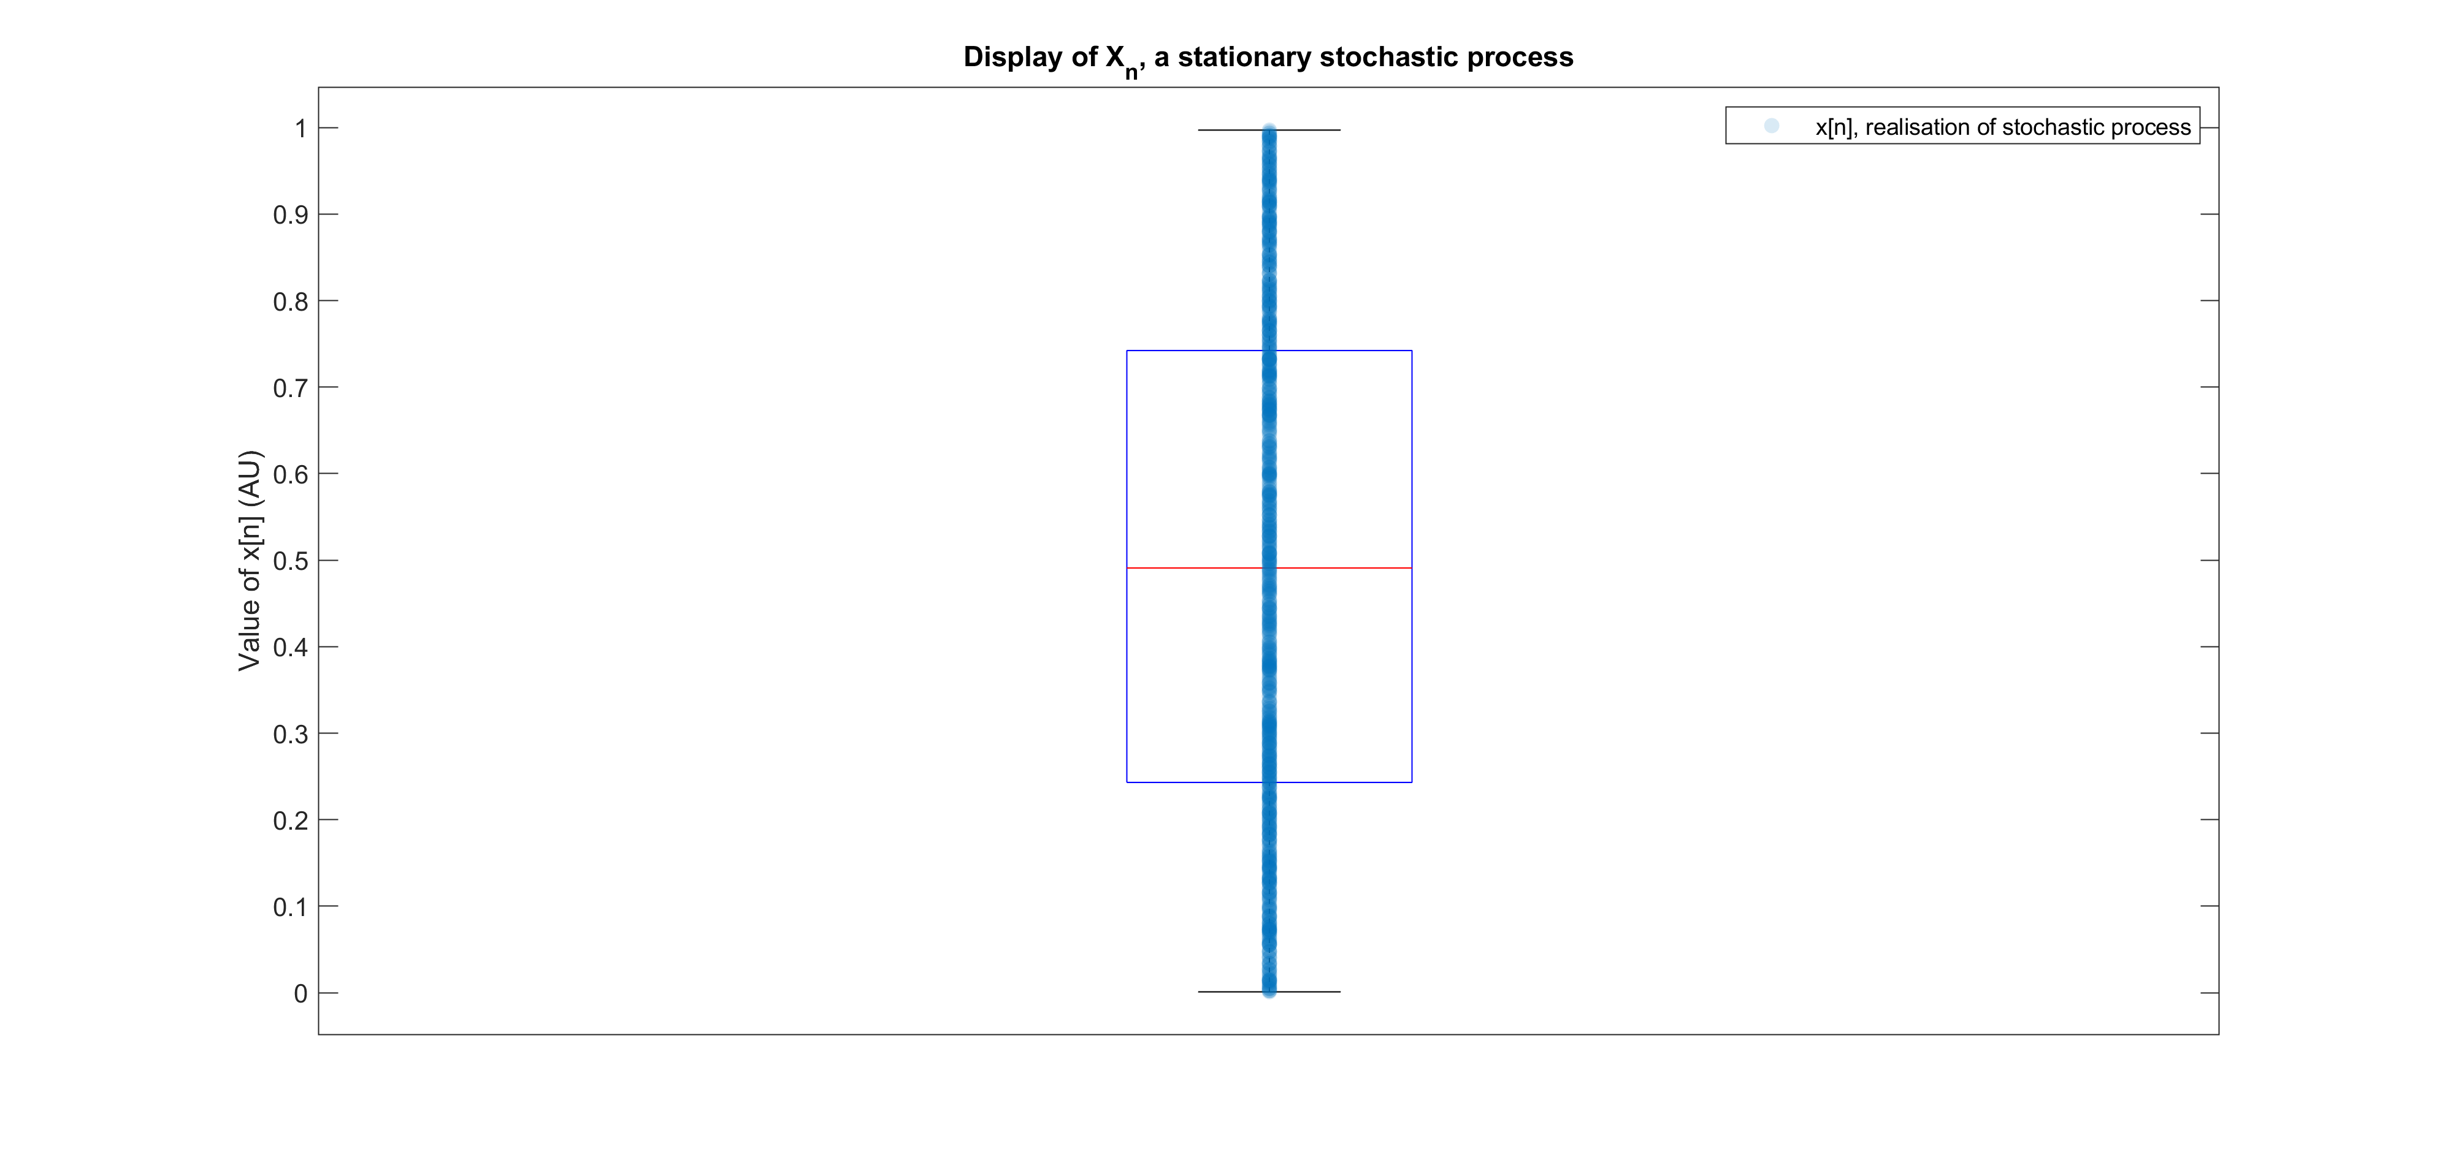Below, a boxplot of a 1000-sample vector generated from the random variable *X ~ U(0, 1)* was plotted.

Figure 1: Boxplot of realisations x[n], overlayed with actual data points.

### Theoretical and sample mean

The theoretical mean can be calculated using the expectation operator,

$$\begin{aligned}E\left(X\right)=\int_{-∞}^{+∞}{αf\left(α\right)}dα\#( SEQ ( \backslash * ARABIC 1 )\end{aligned}$$

where $f\left(x\right)$ is the probability density function (pdf) of the random variable. Since *X* is uniformly distributed between 0 and 1, the pdf has a constant value of 1 in that interval, and we can calculate:

$$\begin{aligned}E\left(X\right)=\int_{0}^{1}{α}dα=\frac{1}{2}\#( SEQ ( \backslash * ARABIC 2 )\end{aligned}$$

The calculated sample mean, $\hat{m}$ was 0.5084, which is a 1.68% error from the true value of 0.5. Since the sample mean is taken from a finite number of samples it can only approximate the true expected value of X, and there is uncertainty associated with this estimate. Due to the central limit theorem, since we have 1000 samples, the sample mean will tend towards being normally distributed, $\overline{X} \sim N(μ_{X}, {σ_{X}^{2}}/n)$, with the variance of the sample mean proportional to the reciprocal of *n*, the number of samples. Therefore, as the number of samples increases, the uncertainty of the estimator decreases.

Figure 2: Scatter displaying the clustering of sample statistics around their theoretical values.

### Theoretical and Sample Standard Deviation

To calculate the theoretical standard deviation, we use the definition for variance:

$$\begin{aligned}Var\left(X\right)=E\left({\left(X-E\left(X\right)\right)}^{2}\right)\#( SEQ ( \backslash * ARABIC 3 )\end{aligned}$$

After utilising the expected value calculated previously, and using the linearity of the expectation operator, we find that:

$$\begin{aligned}Var\left(X\right)=1/12\end{aligned}$$

$$σ=\frac{1}{\sqrt{12}}$$

The sample standard deviation, $\hat{σ}$ was 0.2920, a 1.15% error on the theoretical value. This aligns with our expectations that the sample standard deviation is an unbiased estimator of the true standard deviation, after having applied Bessel’s correction.

### Bias of estimations

The sample mean and standard deviation are both unbiased estimators, meaning that $E\left(X-\hat{m}\right)=0$. As a result, we should expect those statistics to be clustered around their respective theoretical values. As seen in *Figure 2*, this is shown in our observations, with the sample means and standard deviations being centred on their respective theoretical values of 0.5 and $1/{\sqrt{12}}$. The maximum error was $±0.0115$ for $\hat{m}$ and $±0.0099$ for $\hat{σ}$.

### Approximating the pdf

By plotting a histogram and normalising the frequencies by the total number of samples, we are able to generate an approximation of the pdf for the random variable, *X*. In *Figure 3*, the theoretical pdf for the standard uniform distribution is also displayed for comparison.

Figure 3: Histogram plot for a realisation of the stochastic process, X.

As the number of generated samples increases, the approximate pdf tends towards the theoretical pdf of a horizontal line. This is because the single realisation, *x[n],* is better able to represent the entire stochastic process. For example, since this process is ergodic, as the number of samples increases, the time average becomes closer to averaging over an infinite number of samples.

### Gaussian random variables

Now, using the randn function to generate samples from a zero-mean, unit-variance Gaussian distribution, we may repeat the analysis carried out above.

After generating a 1000-sample realisation of this new stochastic process, the sample mean and standard deviation were 0.0319 and 0.9675 respectively. This corresponds to $±0.0319$ error on the theoretical mean value of 0, and $±0.0325$ error on the theoretical standard deviation of 1. These errors again align with our expectations that the estimators are unbiased. This is further supported by *Figure 4*, with the tight clustering of $\hat{m}$ and $\hat{σ}$ to their respective theoretical values.

Figure 4: Scatter displaying the bias of the sample means and standard deviations.

Finally, the approximate pdf was then plotted in *Figure 5*. We observe again that histogram approximates the theoretical Gaussian pdf, and converges as the number of samples increases.

## Stochastic Processes

Figure 5: Histogram displaying the approximation of the theoretical Gaussian PDF.

### Stationarity

Below, plots have been generated to display the ensemble means and standard deviations over time for ensembles from each of the three random processes. For each random process, an ensemble of M=100 members, each with N=100 samples have been generated.

Figure 6: Plot of ensemble statistics over time for random process 3.

Figure 7: Plot of ensemble statistics over time for random process 2.

Figure 8: Plot of ensemble statistics over time for random process 1.

In *Figure 6*, we observe that the ensemble mean increases approximately linearly over time, and the standard deviation has a quadratic dependence. As a result, we conclude that random process 1 (rp1) is not stationary, since these second order moments are not constant over time.

In both *Figure 7* and *Figure 8*, the ensemble statistics appear to be uniformly distributed over time. They are not however exactly constant over time. We may still hypothesise that these random processes are stationary as we should expect a degree of uncertainty in ensemble statistics since we are considering a finite number of members in the ensembles.

### Ergodicity

Now, we consider M = 4 realisations of length N = 1000 for each of the three random processes. The following mean and standard deviations for each realisation were obtained.

|  |  |  |
| --- | --- | --- |
| Realisation | Time average | Standard Dev. |
| 1 | 10.0319 | 5.8650 |
| 2 | 10.0317 | 5.8774 |
| 3 | 9.9959 | 5.8953 |
| 4 | 10.0107 | 5.8576 |

Table 1: Time averages and standard deviations for realisations of random process 1

|  |  |  |
| --- | --- | --- |
| Realisation | Time average | Standard Dev. |
| 1 | 0.5378 | 0.1371 |
| 2 | 0.7956 | 0.1714 |
| 3 | 0.9768 | 0.1244 |
| 4 | 0.0741 | 0.2484 |

Table 2: Time averages and standard deviations for realisations of random process 2

|  |  |  |
| --- | --- | --- |
| Realisation | Time average | Standard Dev. |
| 1 | 0.5156 | 0.8559 |
| 2 | 0.4782 | 0.8640 |
| 3 | 0.5257 | 0.8744 |
| 4 | 0.4582 | 0.8871 |

Table 3: Time averages and standard deviations for realisations of random process 3

We previously established that random process 1 was not stationary, this necessarily implies that this process is not ergodic, since ergodicity is defined only for stationary processes. This can also be seen as the time average is drastically different from the ensemble averages calculated previously. Since M = 1000 is 10 times longer than the previous realisation, and the ensemble mean was increasing linearly, it explains why the time average is higher for the longer realisation.

In *Table 2*, the time averages are significantly different to the ensemble averages, with a large degree of variability, even though the standard deviation values were low. This suggests that this process is not ergodic, since the time averages are not able to approximate the ensemble averages accurately.

Finally in *Table 3*, we observe that time averages of the realisations are equal approximately to 0.5 at 1 s.f. This agrees with the ensemble average values which are approximately centred around 0.5 over time. Since this process seems stationary, we may also hypothesise that this process is ergodic in the mean, since the time average is able to approximate the ensemble average. Generally, for a process to be ergodic in the mean, the sample mean $\hat{m_{x}}\left(N\right)$ is asymptotically unbiased towards the ensemble mean, $m_{x}$:

$$\lim_{N→∞}E\left(\hat{m_{x}}\left(N\right)\right)=m_{x}$$

### Mathematical description

Random process 1 is an amplified sinusoid that has been biased and corrupted by a uniformly distributed noise.

$$x\left[n\right]=Asin\left(n+ϕ\right)+b$$

The theoretical mean will be the bias term, b or Ac in the code.

Random variables from random process 3 are uniformly distributed between – 1 and 2.

$$X\sim U\left(-1,2\right)$$

The theoretical mean will be 0.5 and the variance will be $\frac{{\left(b-a\right)}^{2}}{12} = ¾$.

## Estimation of probability distribution

### pdf generation file

By utilising the histogram function in MATLAB, we are able to obtain an estimate of the pdf of a collection of samples taken from a random process.

The following plot was obtained from the pdf m-file.

### Using custom function

Figure 9: PDF estimation from a collection of N=500 samples taken from a Gaussian pdf.

### Difficulties with non-stationary processes

It is not possible to estimate the pdf of a nonstationary process with this current function. This is because the pdf will change in time, meaning a new pdf will have to be generated to reflect the changes. For the given example, you could tackle this challenge by splitting the signal into 2 sections, from N = 1 to 500 before the pdf changes, and then N= 501 to 1000. By generating separate pdfs for each section, you’ll more accurately model the nonstationary process.

# Linear Stochastic Modelling

## Autocorrelation of uncorrelated and correlated sequences

### Autocorrelation of White Gaussian Noise

The function xcorr was used to plot the autocorrelation function (ACF) for a 1000-sample realisation of WGN with zero mean and unit variance. This function utilises an unbiased estimator given by

$$\begin{aligned}{\hat{R}}_{X}\left(τ\right)=\frac{1}{N-\left|τ\right|}\sum_{n=0}^{N-τ-1}{x\left[n\right]x\left[n+τ\right]}\#\left(1\right)\end{aligned}$$

Theoretically, an independent stochastic process will have an ACF in the form of a discrete Dirac function, since samples at different times will not be correlated with one another. We observe a peak value of 1 at the autocorrelation lag $τ=0$ since this value corresponds to its variance for a zero-mean process.

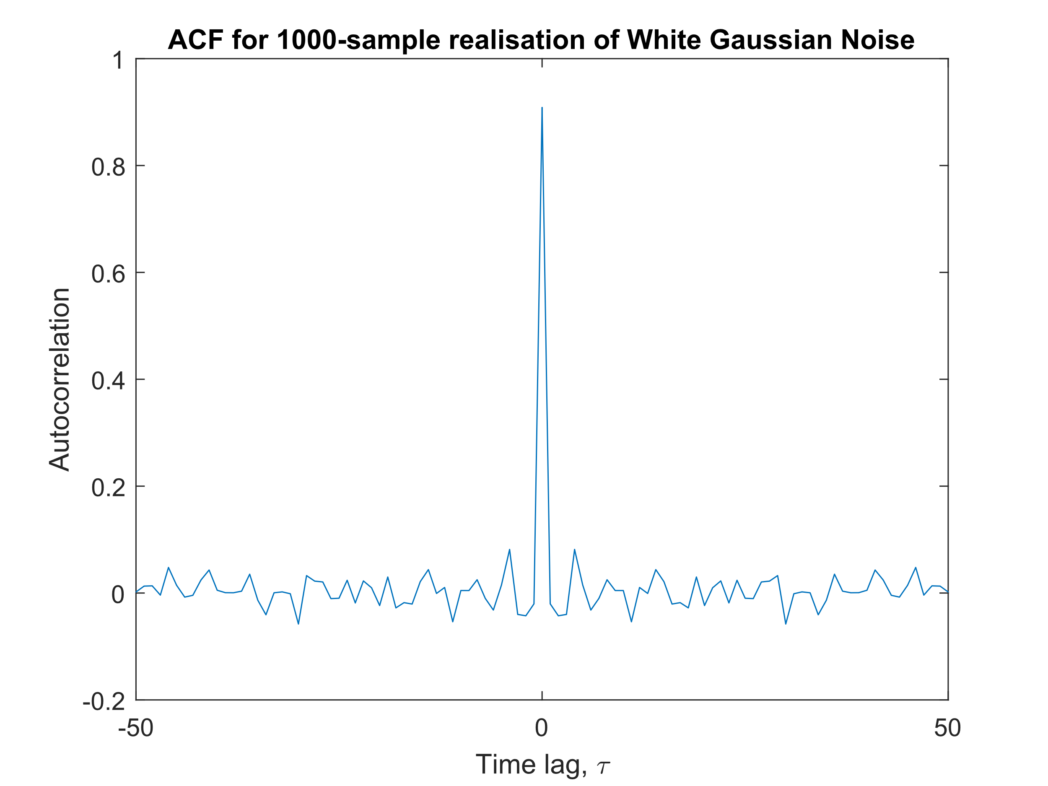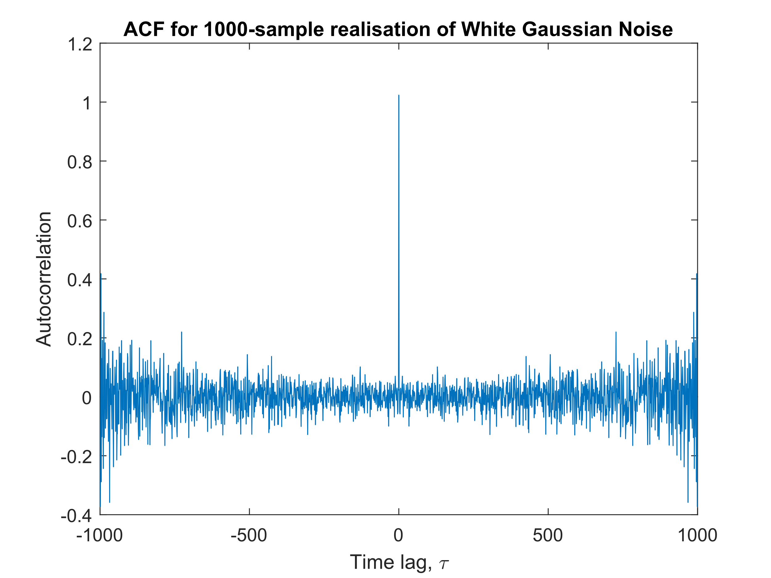

We also observe that the ACF is an even function, since we are considering a stationary process, so the ACF is purely a function of the size of the separation lag. Hence, ${\hat{R}}_{X}\left(τ\right)≈{\hat{R}}_{X}\left(-τ\right)$.

### Large vs small $τ$

As autocorrelation lag $\left|τ\right|$ increases, there are less samples to average over, so the variability of the estimate increases. This can be seen in the noise appearing in Figure x (left). For $\left|τ\right| < 50$, the estimate has less variability around the theoretical value of 0, since the estimation is averaged over more samples.

### Accuracy of ACF estimates for varying autocorrelation lag

As seen in Eqn (x), as $\left|τ\right|$ increases, $N-\left|τ\right|-1$ decreases, meaning the summation is over less terms and the average is over less samples. This therefore increases the variance of the estimator, introducing more noise. As a result, ACF estimates for large $\left|τ\right|$ values are not statistically reliable. By allowing a 10% deviation from the true value of 0, an empirical bound of $τ≈$ 300 would be suitable.

### ACF for MA Process

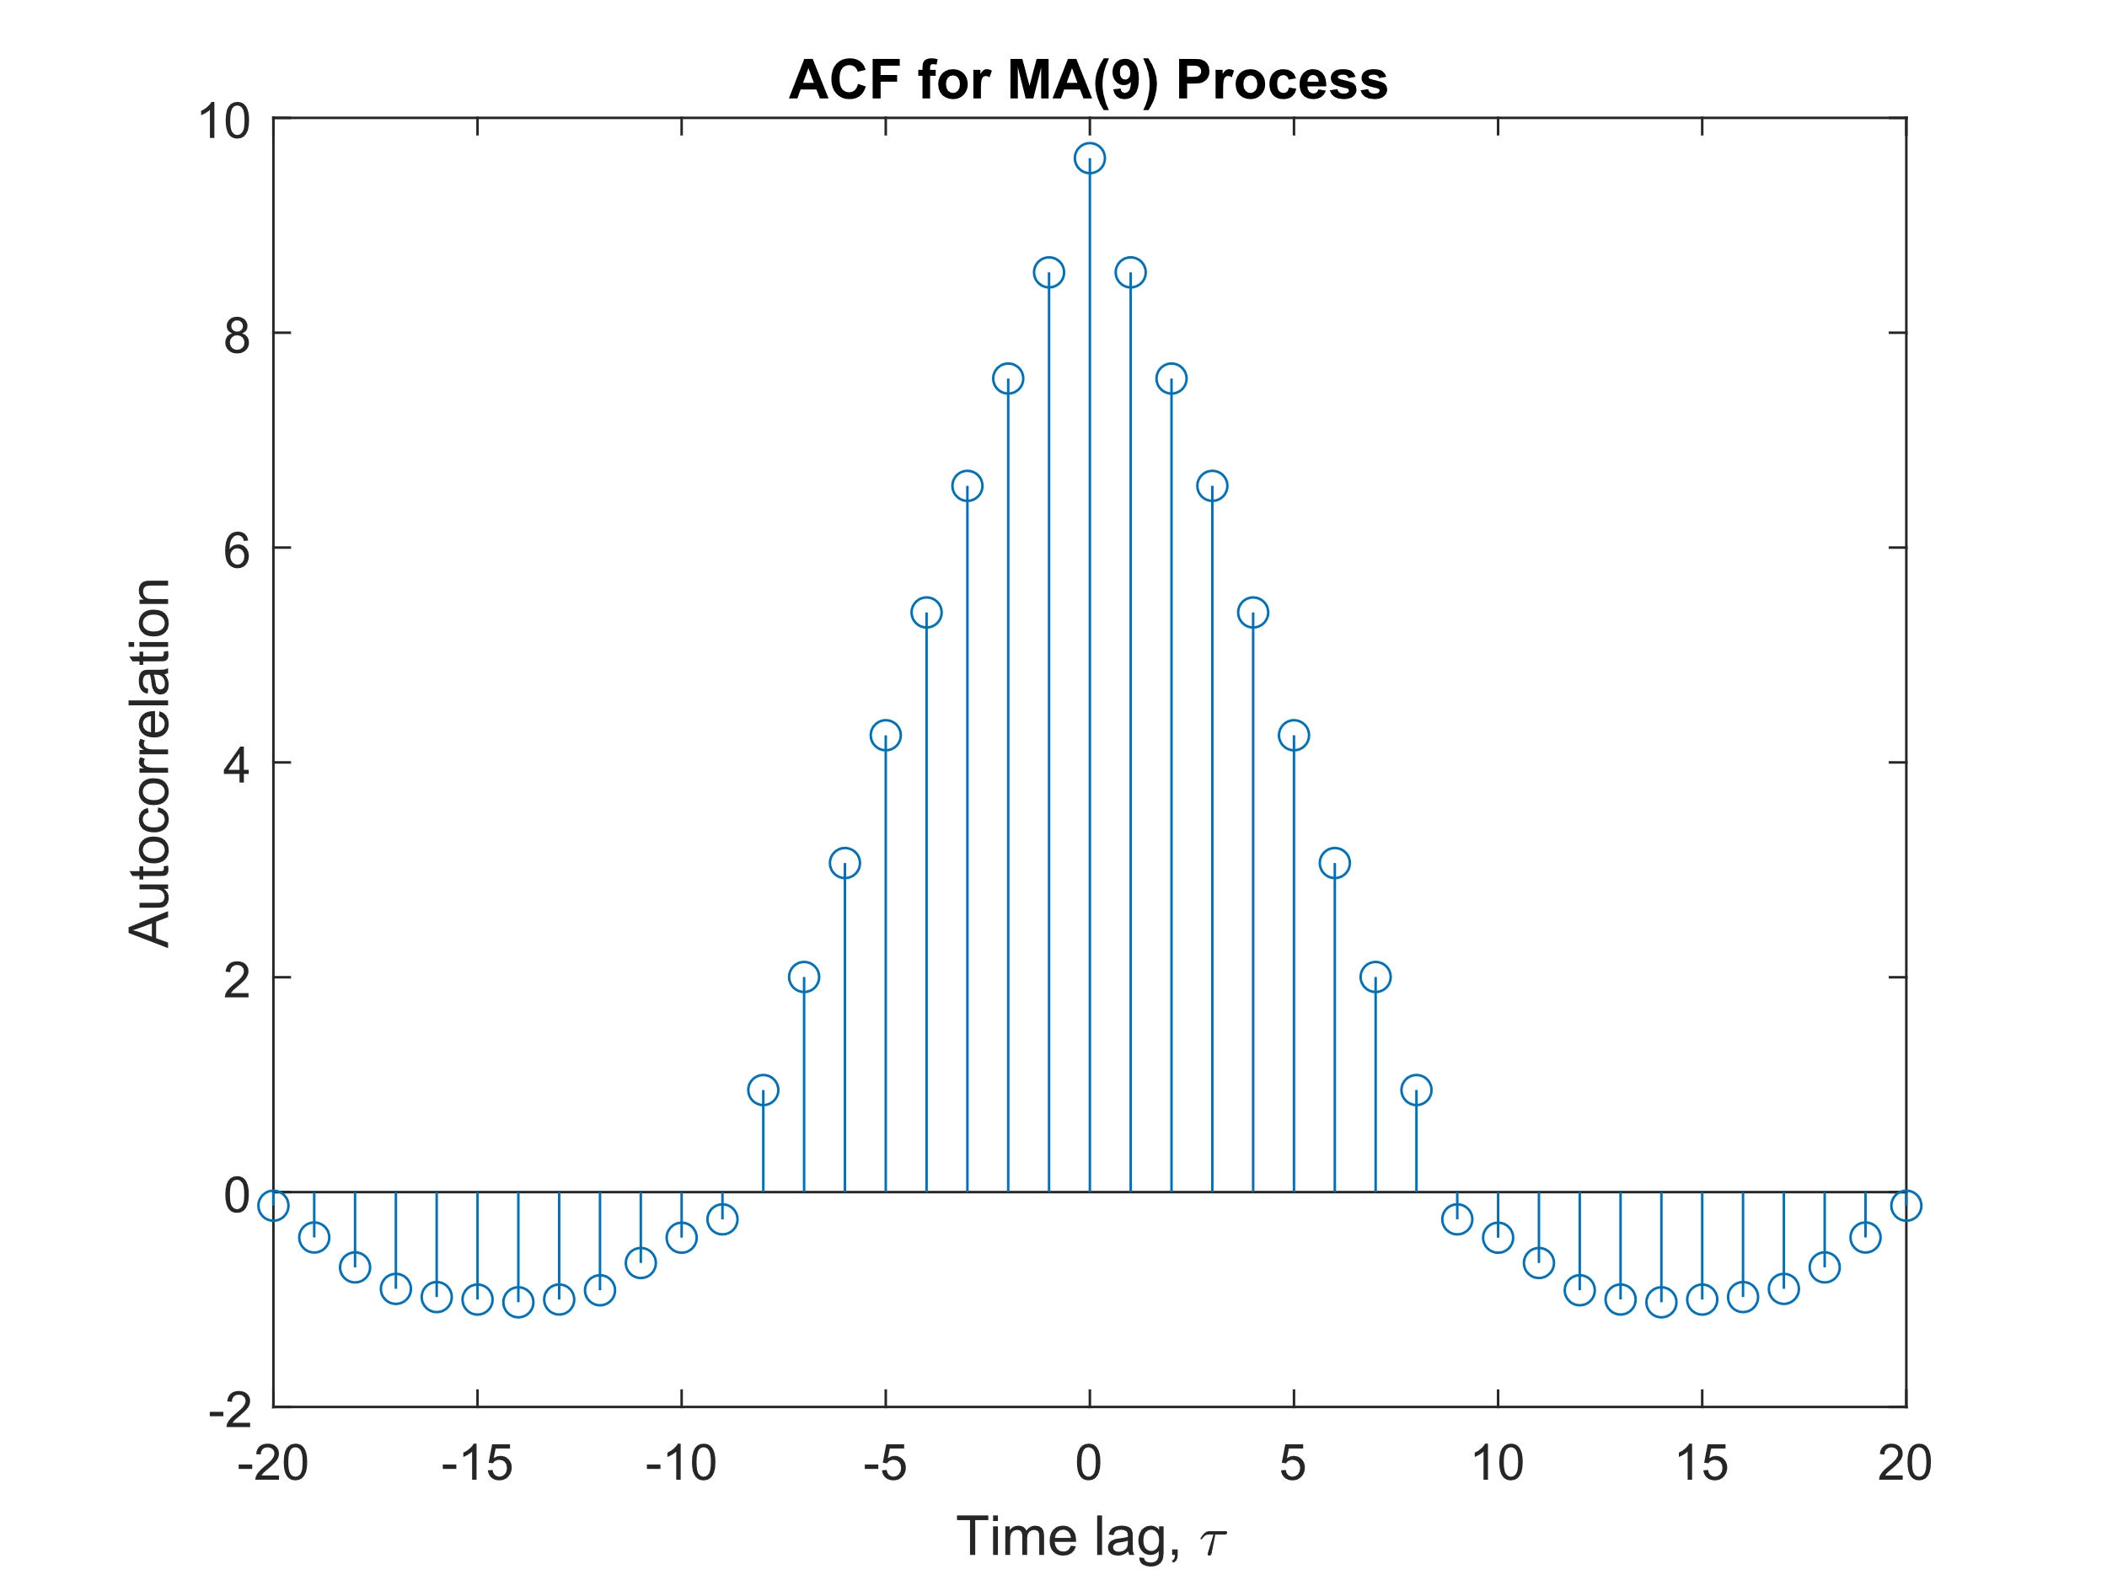By filtering a WGN realisation **x** through an 8th order Moving Average (MA) filter, we obtain a MA(8) process. An arbitrary MA(q) process driven by zero-mean WGN can be shown as:

$$y\left[n\right]=\sum_{i=0}^{q}{x\left[n-i\right] + w[n], w[n] \sim N(0,σ_{w}^{2}} ).$$

We can therefore calculate the theoretical ACF:

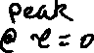

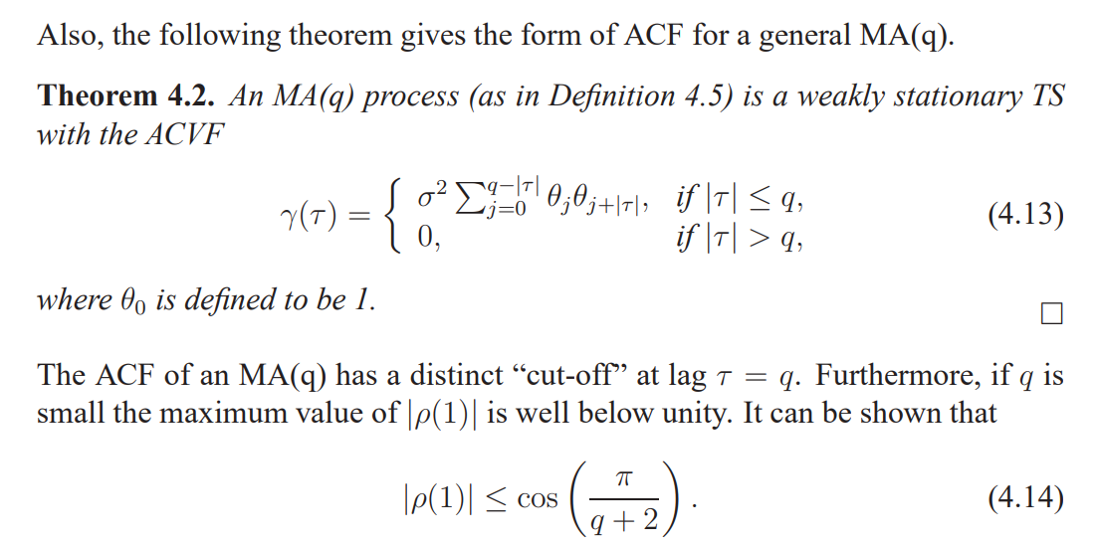



In our case, the MA impulse train is a flat train of delta of length q=9. How did this give rise to quasi-periodicity? **Cut off after time lag q.** As order increases, magnitude of coefficients decrease? What is meant by local sample mean -> Yes it’s calculating it?

### Autocorrelation and Linear Systems

RY (τ ) = RX(τ ) ∗ Rh(τ )

$$R_{Y}\left(τ\right) = \begin{aligned}\sum_{j=0}^{q-\left|τ\right|}{θ_\{j\}θ)\{j+\backslash \backslash tau|\}, if |τ| ≤q,} \\ 0,if\left|τ\right|>q\end{aligned}$$

Rx should be a delta since uncorrelated process, so convolving with Rh, delta * fn = fn. So Ry is the autocorrelation of the filter h. Scaled version of the ACF of the filter.

## Cross-correlation function

### CCF for MA filter

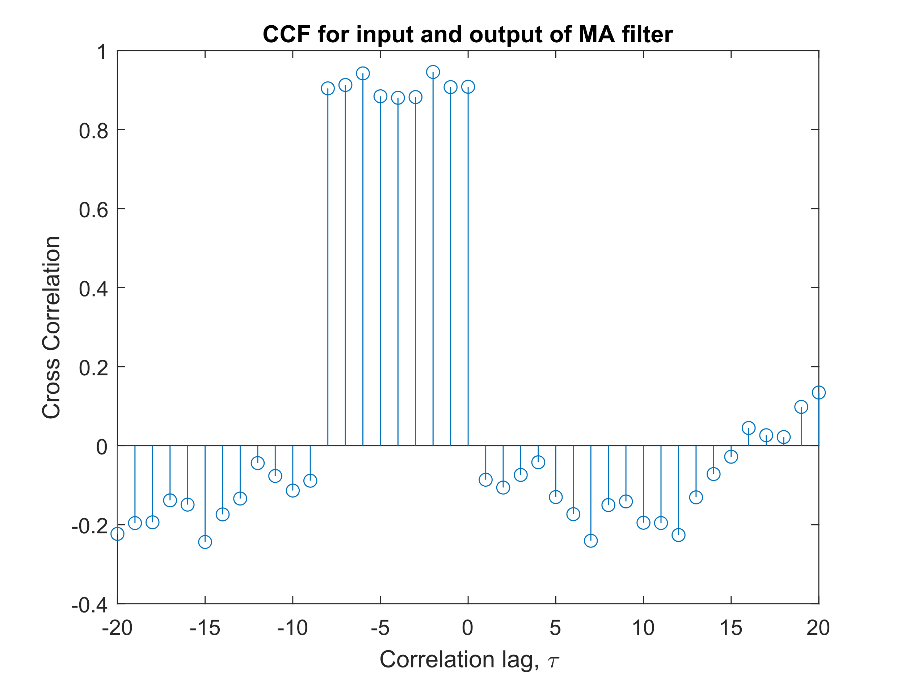

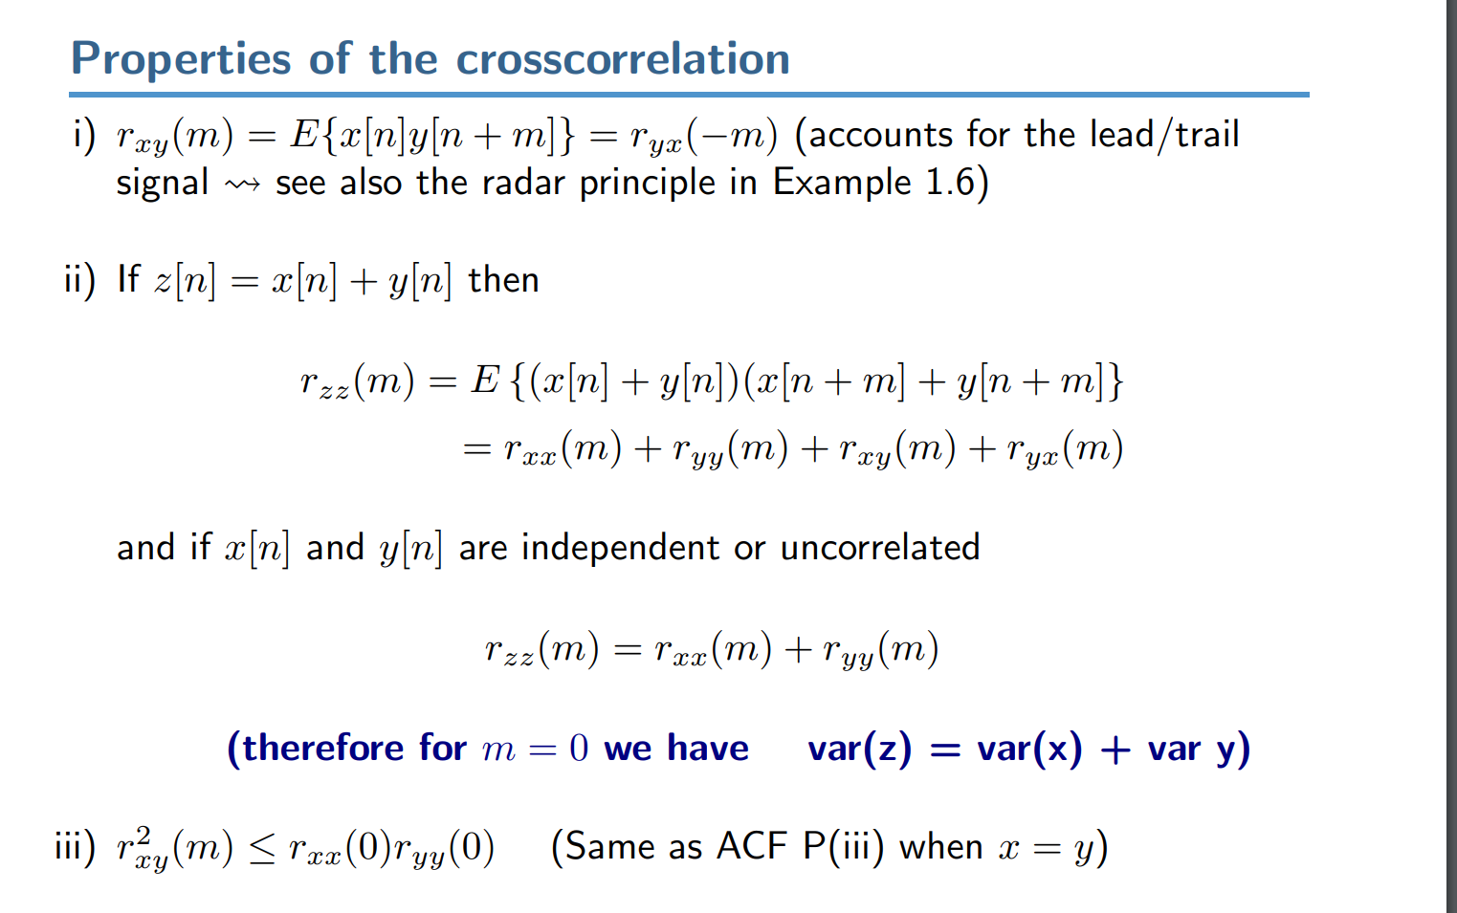Not sure why it’s not centred at 0. Does the MA induce a phase shift into the input?

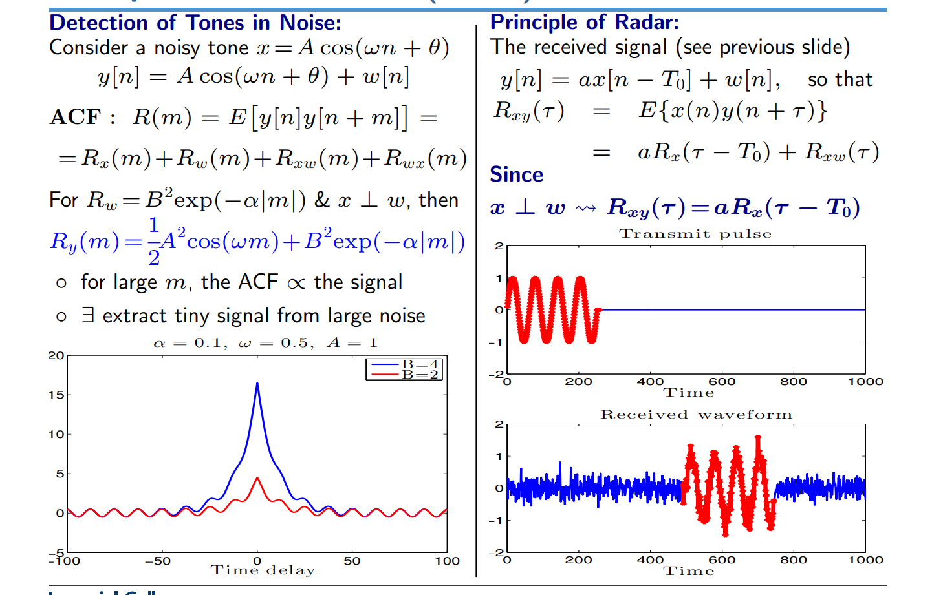

Y = weighted sum of delayed x? So Rxy = a time shifted version of Rxx?

If Xt is uncorrelated stochastic process, Rx = delta spike. Since we have delta * impulse response, Rxy = impulse response. We can see that plus some noise.

### System identification

This is a very useful result. It means that we can estimate the cross-correlation between the input x and y, Rxy. Then provided this is a good estimate, it should approximate the impulse response of the system, which contains all the information needed to describe the system. Higher order MA filters cause longer cross-correlations, does it cause more pseudo-periodicity? Variability/overfitting?

## Autoregressive Modelling

### Stability criteria

The pairs of coefficients $\left(a_{1},a_{2}\right)$ that result in convergence tend to fall within a triangular region. (Check number ~ 1/3 rn) This triangular shape results from the stability criteria imposed by the equation for the variance of an AR(2) process. Since variance must be real and positive, Condition 1 and 2: ${\left(1-a\right)}^{2}>a_{1}^{2}$; Condition 3: $\frac{1-a_{2}}{1+a_{2}} > 0$.

### Sunspot ACF

Error if R[0] not largest?

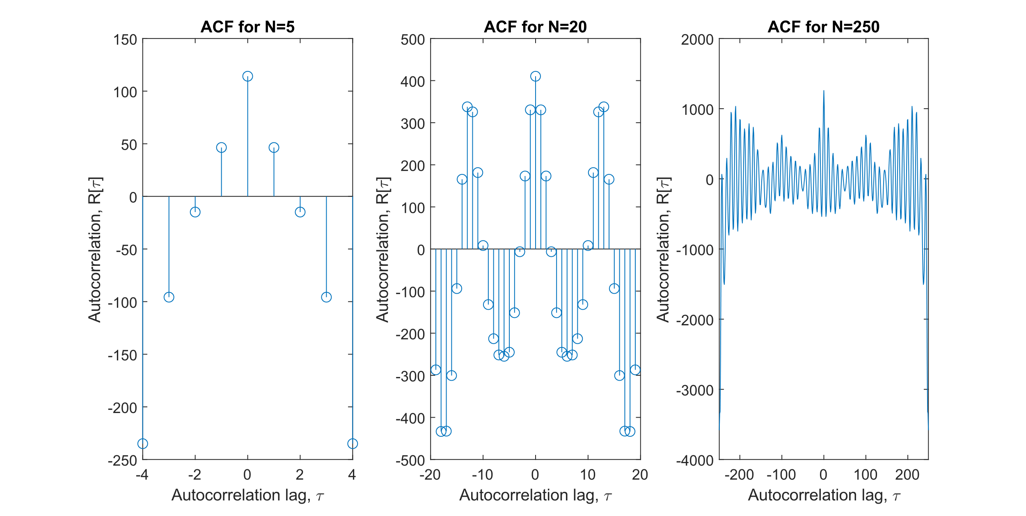Still getting artefacts on estimate of large autocorrelation lags? Or do I find the AR(2) coefficients first and plot the ACF of the AR(2) process?

Without centring the mean on zero, the pseudo-periodicity of the ACF is masked, since the DC level of noise corrupts the ACF with a constant level. The larger the mean, the more corrupted the ACF. After removing the mean, we can see there is pseudo-periodicity in the ACF, suggesting that the characteristic equation for the AR process has complex roots. ~~We know we are in Region IV of the stability triangle, with positive~~

### Yule-Walker Equations and Partial Correlation Functions

## Cramer-Rao Lower Bound

How to find variance of a^? a = rxx(1)/rxx(0) so need to find variance of this? Variance of sum x[n]x[n+m] = Cov(xn, xm)?

## Real world signals: ECG from iAmp experiment

### Heart rate probability density estimate (PDE)

Are the ECG signals correct? Ecg_1 used.

**Should I Keep anomalies or get rid?**

Not sure what the difference is between averaged and raw PDE, I thought averaged would have tighter PDEs since less variance, but actually seem broader peaked.

Lower alpha means lower weighting, also means signal is actually reduced since taking mean then scaling by <1.

### AR modelling of heart rate

If MA, should be a triangle and cut off after lag of order p. AR can have oscillation, why would different trials be different, should they be the same?

Check if AR with matlab function. Find PCF, confidence bounds. MDL AIC. Power spectrum, lack of zeros?

# Spectral Estimation

Results of the pgm function show that the periodogram estimates are incredibly noisy. White gaussian noise should theoretically have a constant PSD with the value equal to the WGN variance. This is because PSD = FT(ACF), ACF = var*delta since each sample is independent and so will not be correlated with another.

## Average periodogram estimates

Filtering slightly helps, still variability

Individual PSD higher variance.

Split into non-overlapping windows and averaged -> Bartlett’s method

Average has lower variance, why is it not centered on 1 (variance of white noise)?

Chi Squared Distribution?

## Spectrum of autoregressive processes

Plot x,y in time domain

### Theoretical PSD

High pass filter since under convention x[n] = sigma akx[n-k] + w[n], a1=-0.9 in our case < 0. Therefore ACF is alternating sign exponential decay, since negatively correlated with previous sample, indicating opposite sign. This indicates high frequency oscillations within the signal. What is the cut-off frequency of a (AR(1)) filter?

### Periodogram

Noise in periodogram since it is a RV ~ X^2. Still follows general high pass shape but lower at highest frequencies.

### Differences between Periodogram

What does rectangular windowing on periodogram do? Increase variance? Finite y sample.

### Estimating parameters and model-based PSD

Ry[0] = 5.6540; Ry[1] = -5.1140

$$\hat{a_{1}}=-\frac{\hat{R_{Y}}\left(1\right)}{\hat{R_{Y}}\left(0\right)}=0.9045$$

$$\hat{σ_{X}^{2}}=\hat{R_{Y}}\left(0\right)+\hat{a_{1}}\hat{R_{Y}}\left(1\right) = 1.0284$$

$${\hat{P}}_{Y}\left(f\right)=\frac{{\hat{σ}}_{X}^{2}}{{\left|1+{\hat{a}}_{1}e^{-j2πf}\right|}^{2}}$$

### Sunspot spectrum modelling

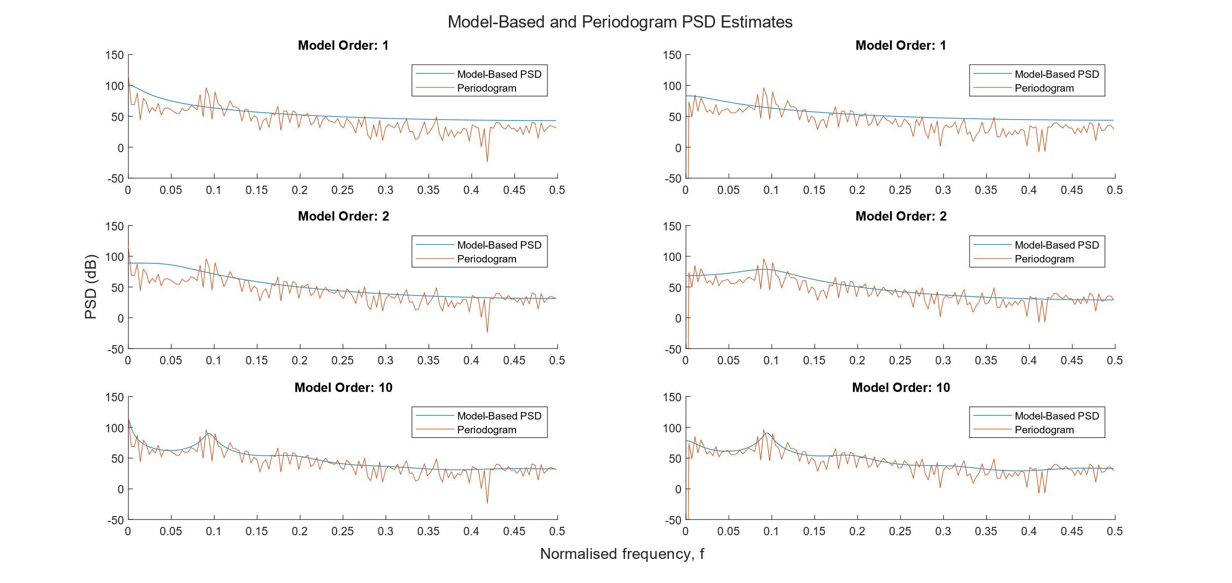

Spurious peaks in frequency spectra, overfitted to data, low interpolation error will not generalise well (when extrapolating)

## The Least Squares Estimation (LSE) of AR Coefficients

### Least Squares Estimates for coefficients, **a**

See onenote

The form of least squares estimator is similar to form of solution to Yule-Walker equations. Observation matrix is similar to Rxx matrix, but extended lengthways (m-wise) past m=p, to m=M-1 (Tall matrix with M>p).

### Stochasticity of observation matrix, **H**

Observation matrix is now full of estimates / random variables, making it stochastic.

|  |  |  |  |  |  |  |  |  |  |  |  |
| --- | --- | --- | --- | --- | --- | --- | --- | --- | --- | --- | --- |
|  | Coefficient | |  |  |  |  |  |  |  |  | Error |
| Order | a1 | a2 | a3 | a4 | a5 | a6 | a7 | a8 | a9 | a10 |  |
| AR(1) | 0.8219 | 0.0000 | 0.0000 | 0.0000 | 0.0000 | 0.0000 | 0.0000 | 0.0000 | 0.0000 | 0.0000 | 92.06109 |
| AR(2) | 1.3864 | -0.6853 | 0.0000 | 0.0000 | 0.0000 | 0.0000 | 0.0000 | 0.0000 | 0.0000 | 0.0000 | 48.79046 |
| AR(3) | 1.3076 | -0.5272 | -0.1145 | 0.0000 | 0.0000 | 0.0000 | 0.0000 | 0.0000 | 0.0000 | 0.0000 | 48.08165 |
| AR(4) | 1.3126 | -0.4989 | -0.1833 | 0.0515 | 0.0000 | 0.0000 | 0.0000 | 0.0000 | 0.0000 | 0.0000 | 47.91566 |
| AR(5) | 1.3135 | -0.5020 | -0.1918 | 0.0740 | -0.0171 | 0.0000 | 0.0000 | 0.0000 | 0.0000 | 0.0000 | 47.9016 |
| AR(6) | 1.3172 | -0.5140 | -0.1613 | 0.1574 | -0.2342 | 0.1665 | 0.0000 | 0.0000 | 0.0000 | 0.0000 | 46.55051 |
| AR(7) | 1.2876 | -0.4702 | -0.1972 | 0.1918 | -0.1211 | -0.1194 | 0.2123 | 0.0000 | 0.0000 | 0.0000 | 43.5153 |
| AR(8) | 1.2412 | -0.4468 | -0.1669 | 0.1492 | -0.0798 | -0.0101 | -0.0841 | 0.2331 | 0.0000 | 0.0000 | 41.1561 |
| AR(9) | 1.1936 | -0.4310 | -0.1628 | 0.1660 | -0.1127 | 0.0243 | 0.0067 | -0.0211 | 0.2085 | 0.0000 | 39.38904 |
| AR(10) | 1.1883 | -0.4298 | -0.1654 | 0.1683 | -0.1110 | 0.0191 | 0.0112 | -0.0105 | 0.1787 | 0.0249 | 39.35548 |

### Sunspot series LSE approach

### Model Order Selection

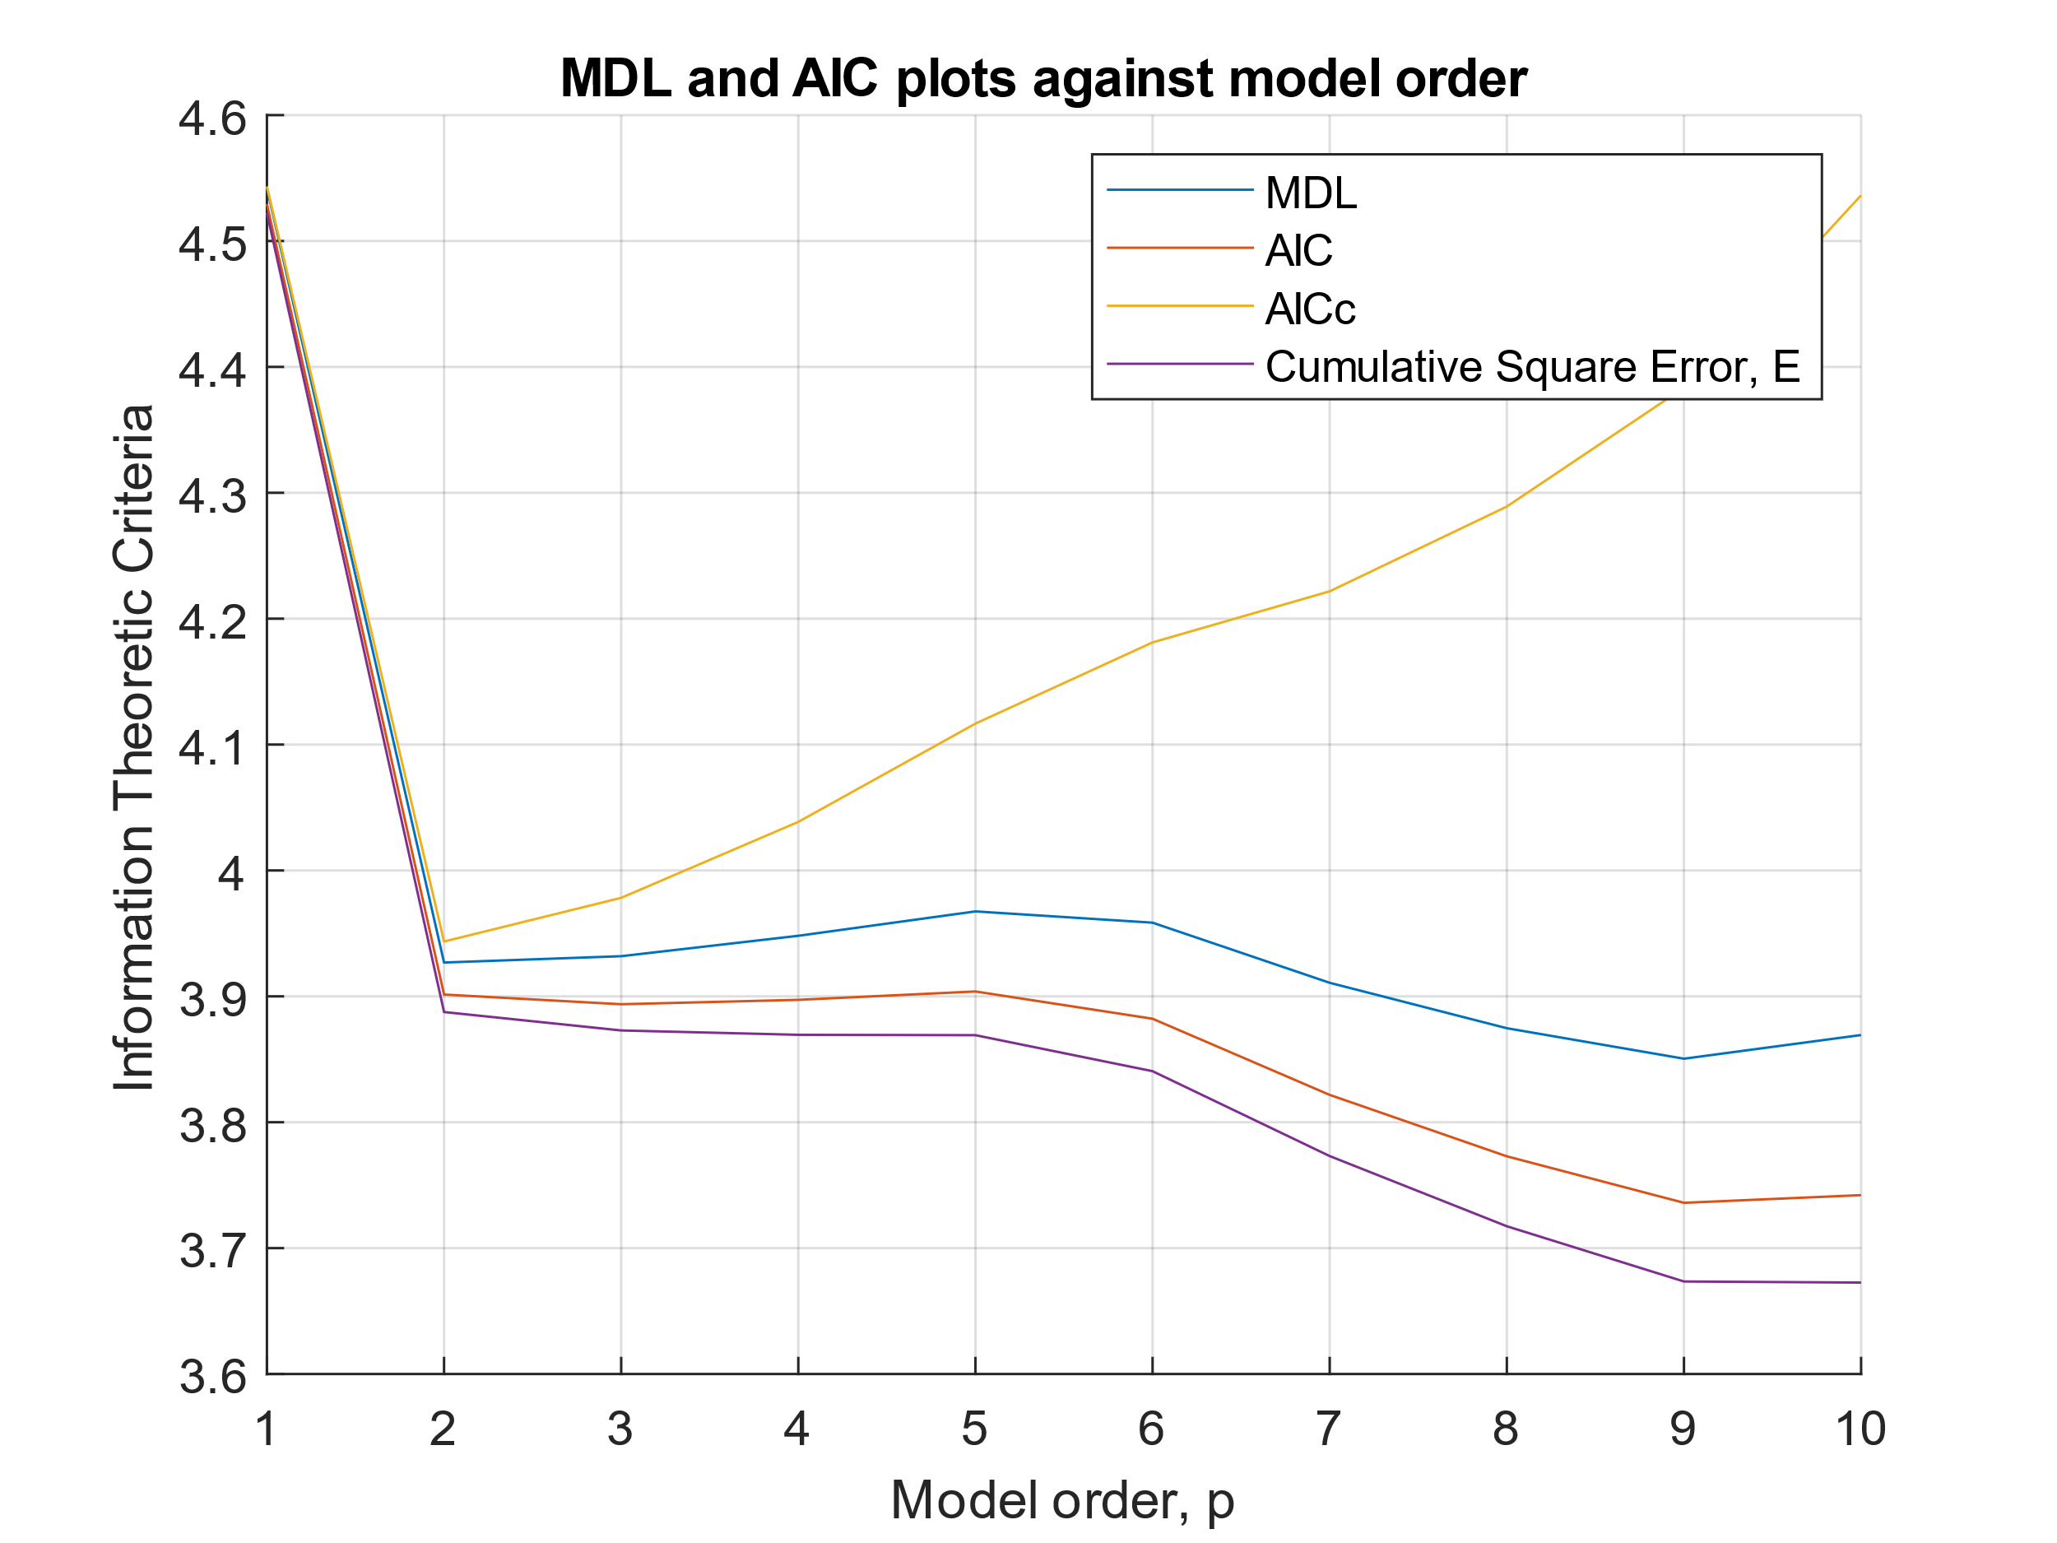

### Power Spectra of AR(p) models

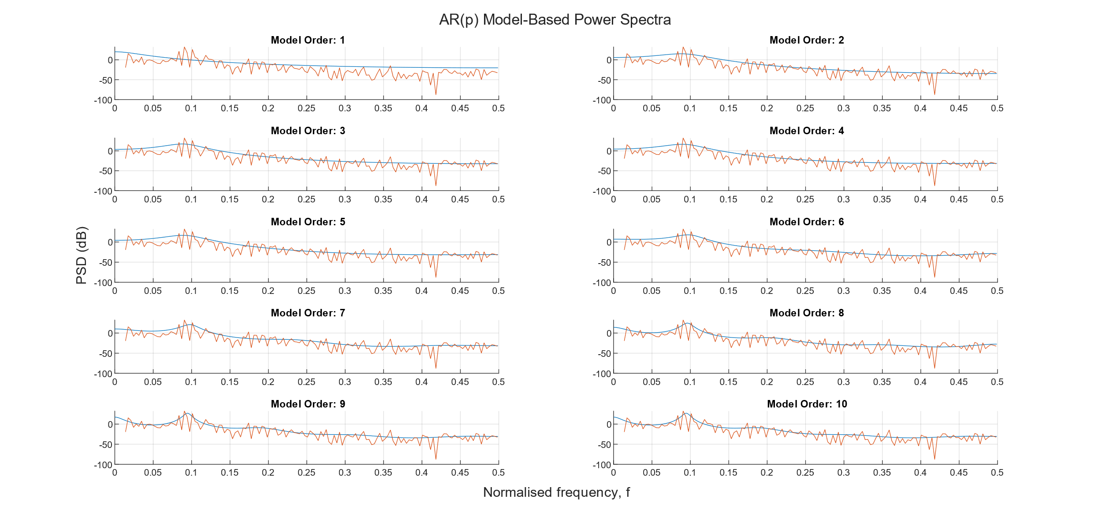

### Approximation Error for Optimal AR(p) model with varying data length

## Spectrogram for time-frequency analysis: dial tone pad

### Generating a random DTMF signal

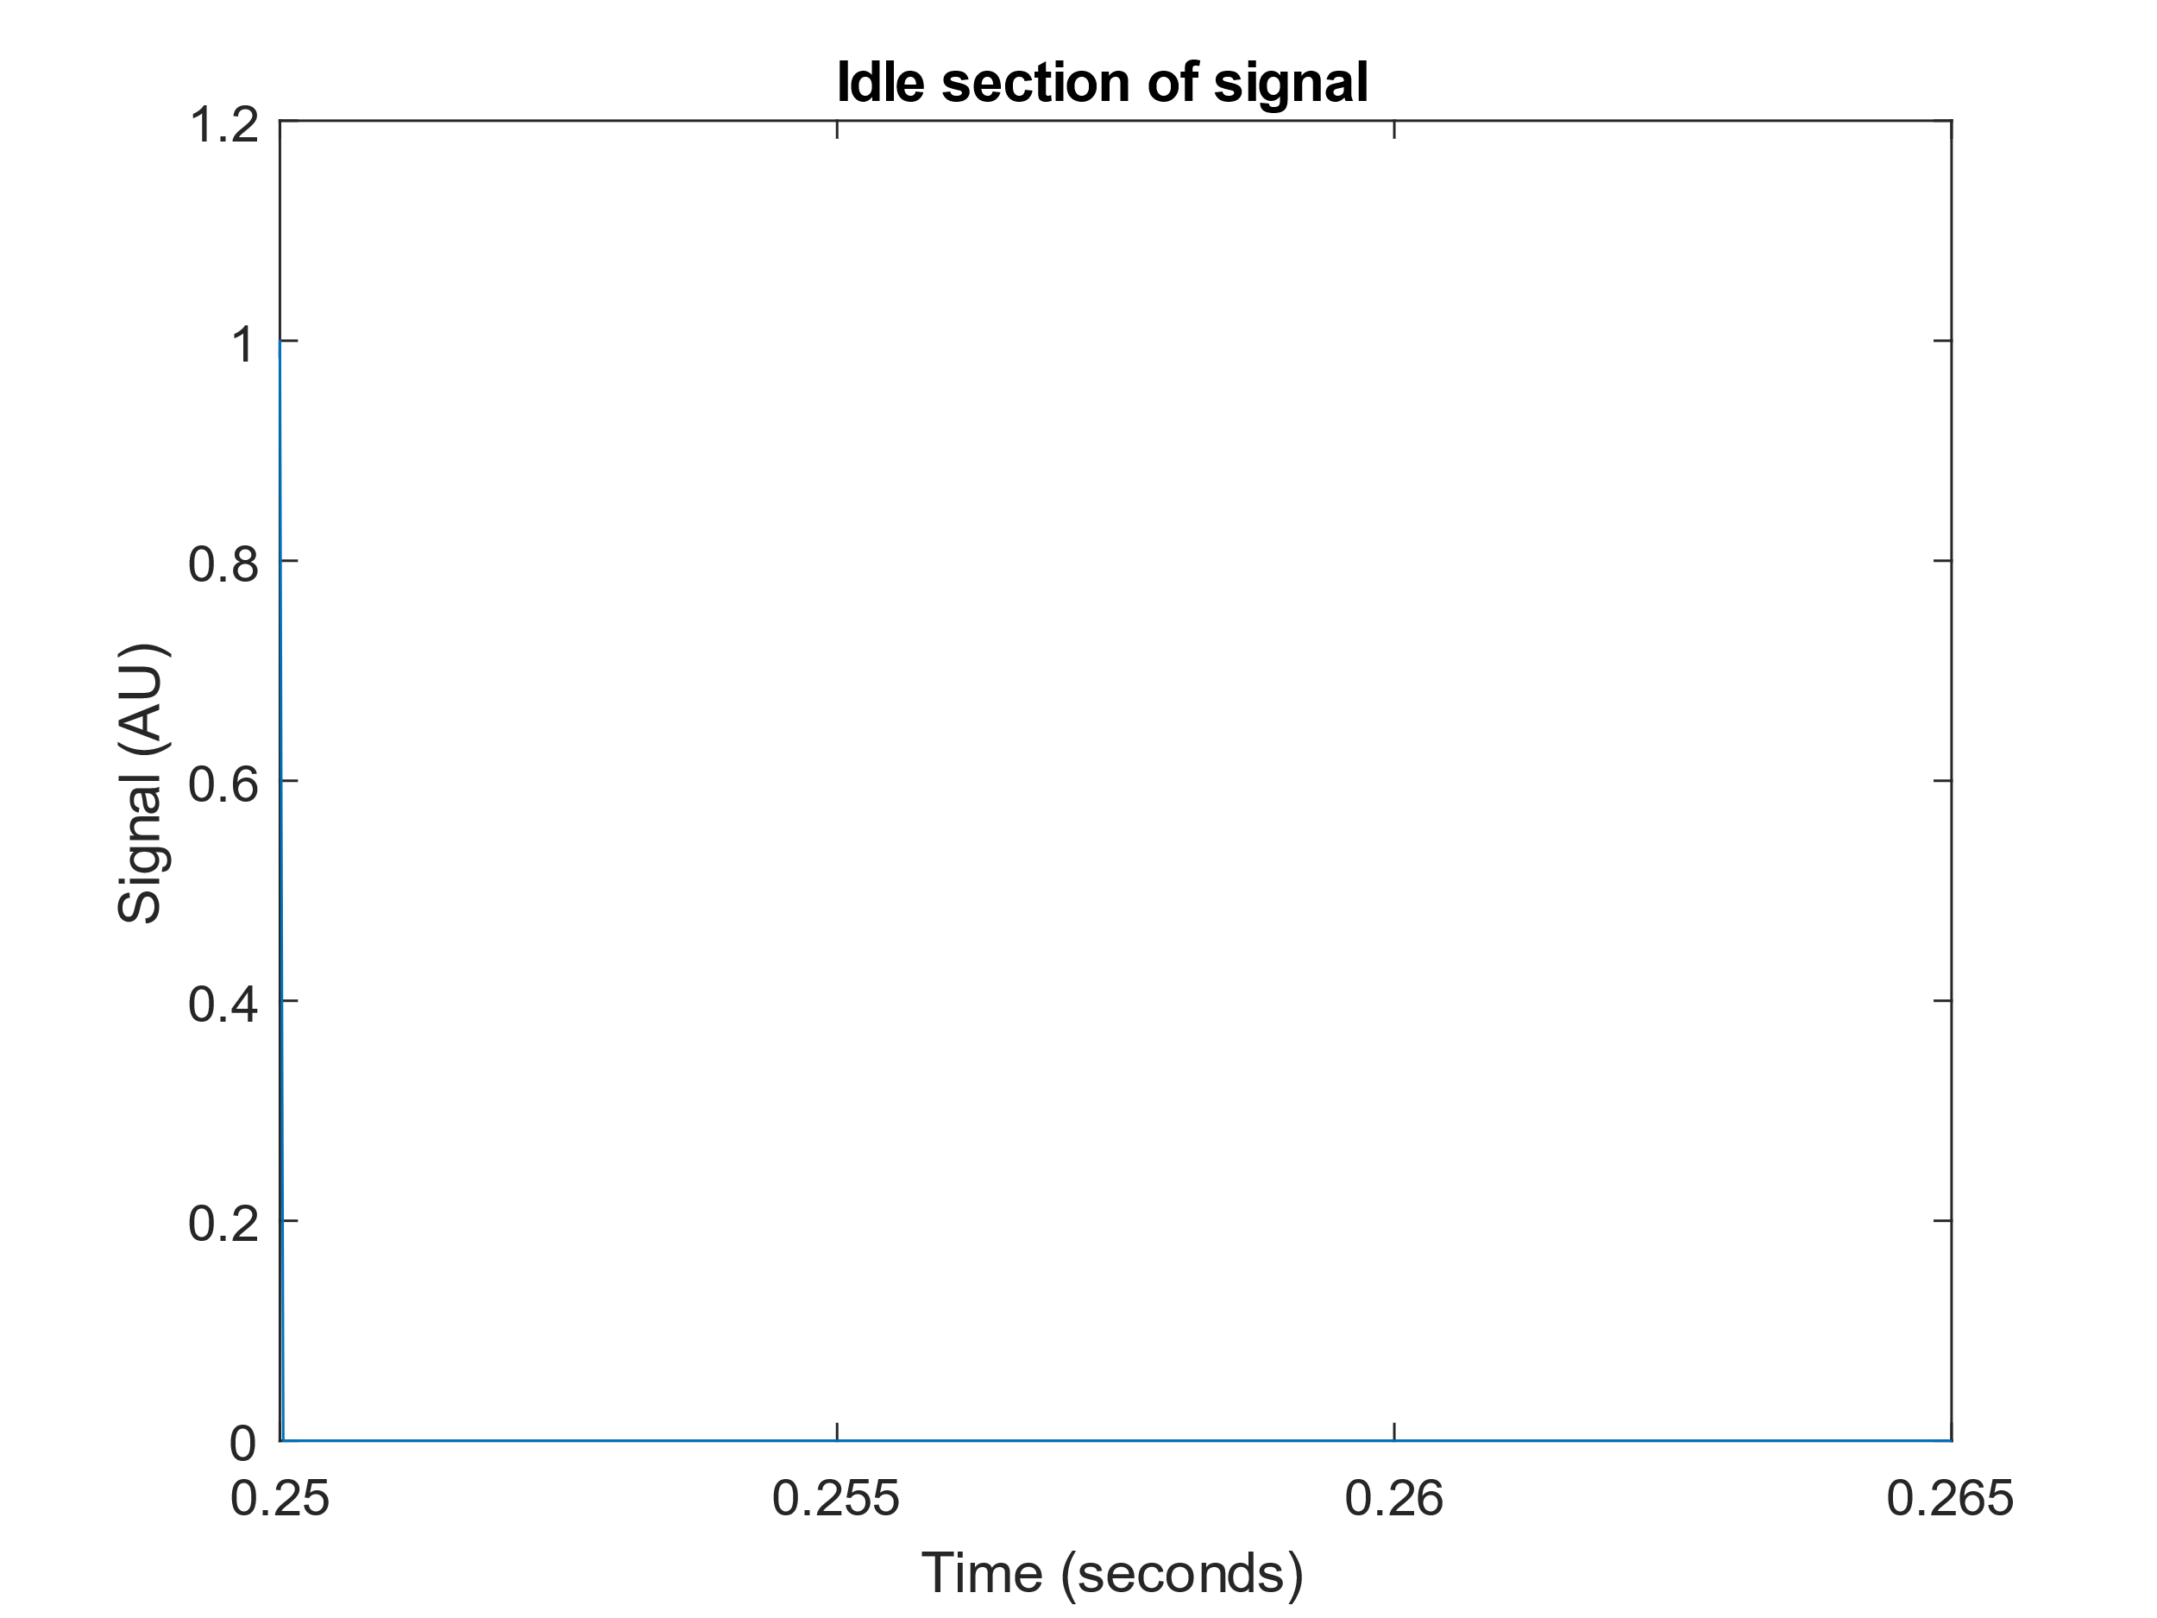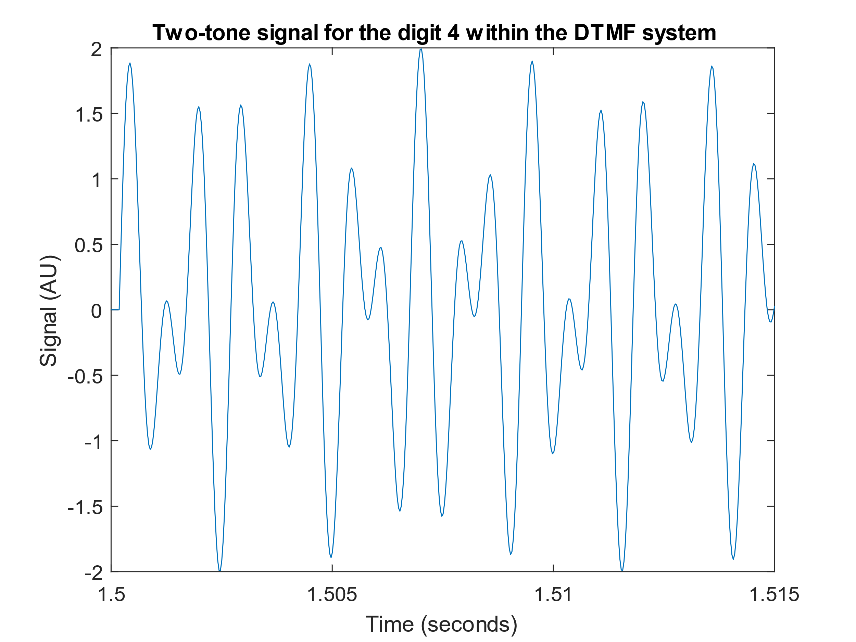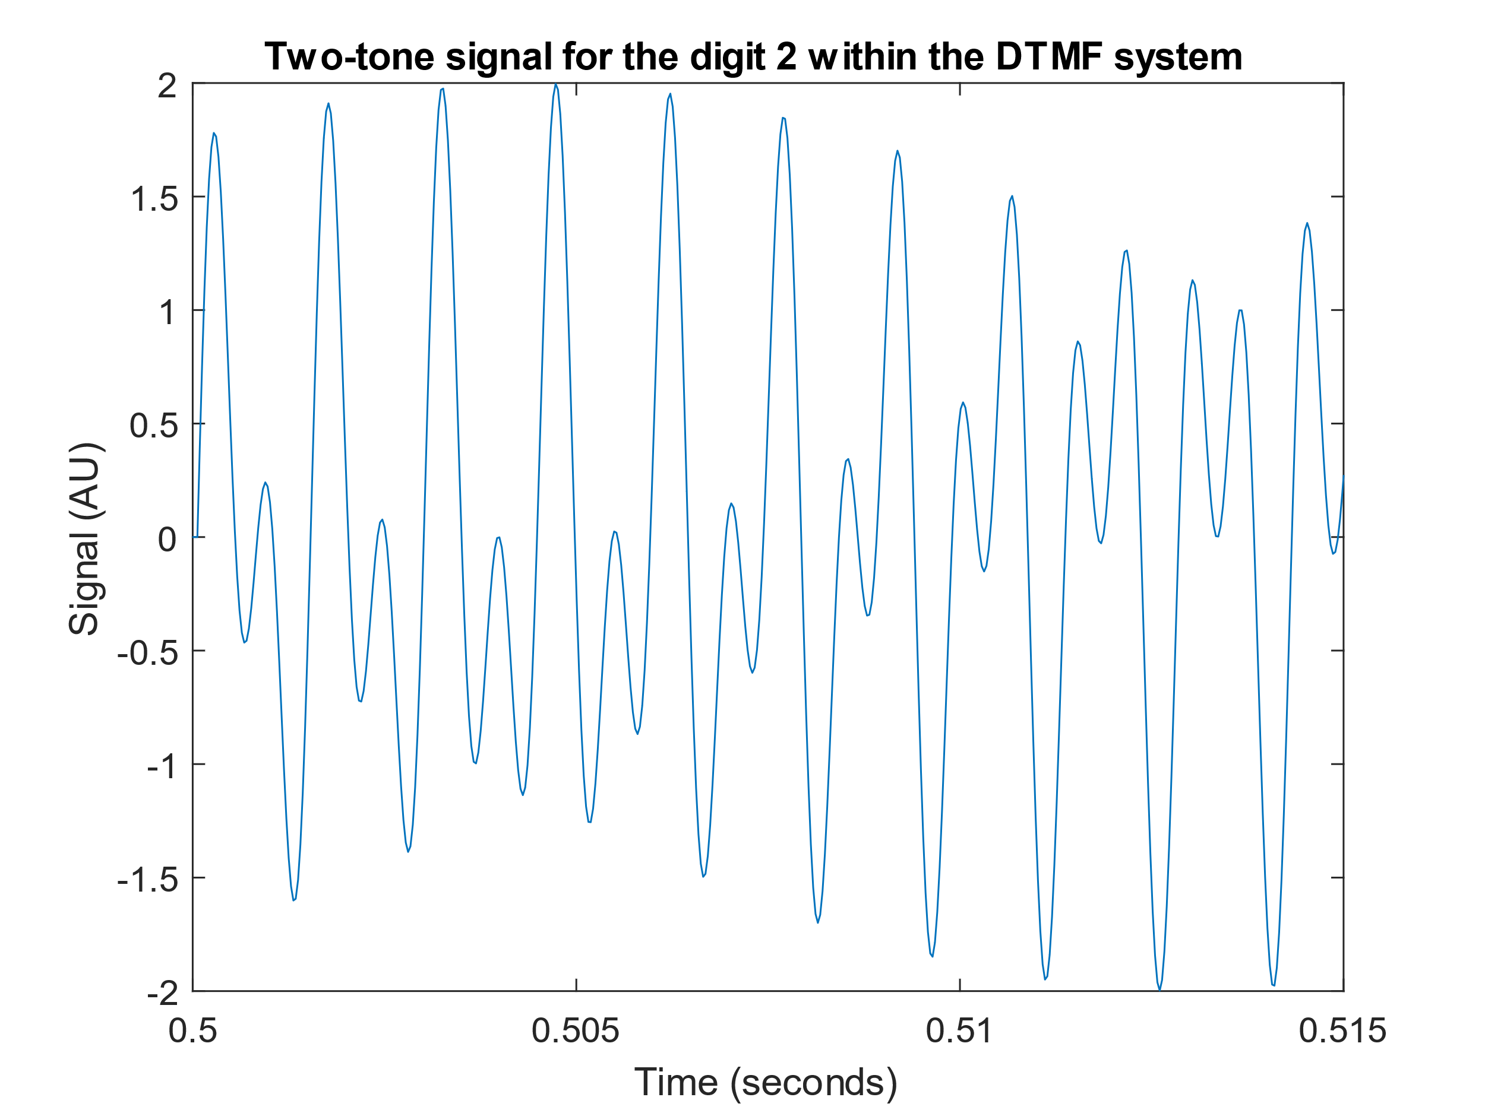

### Spectrogram estimate

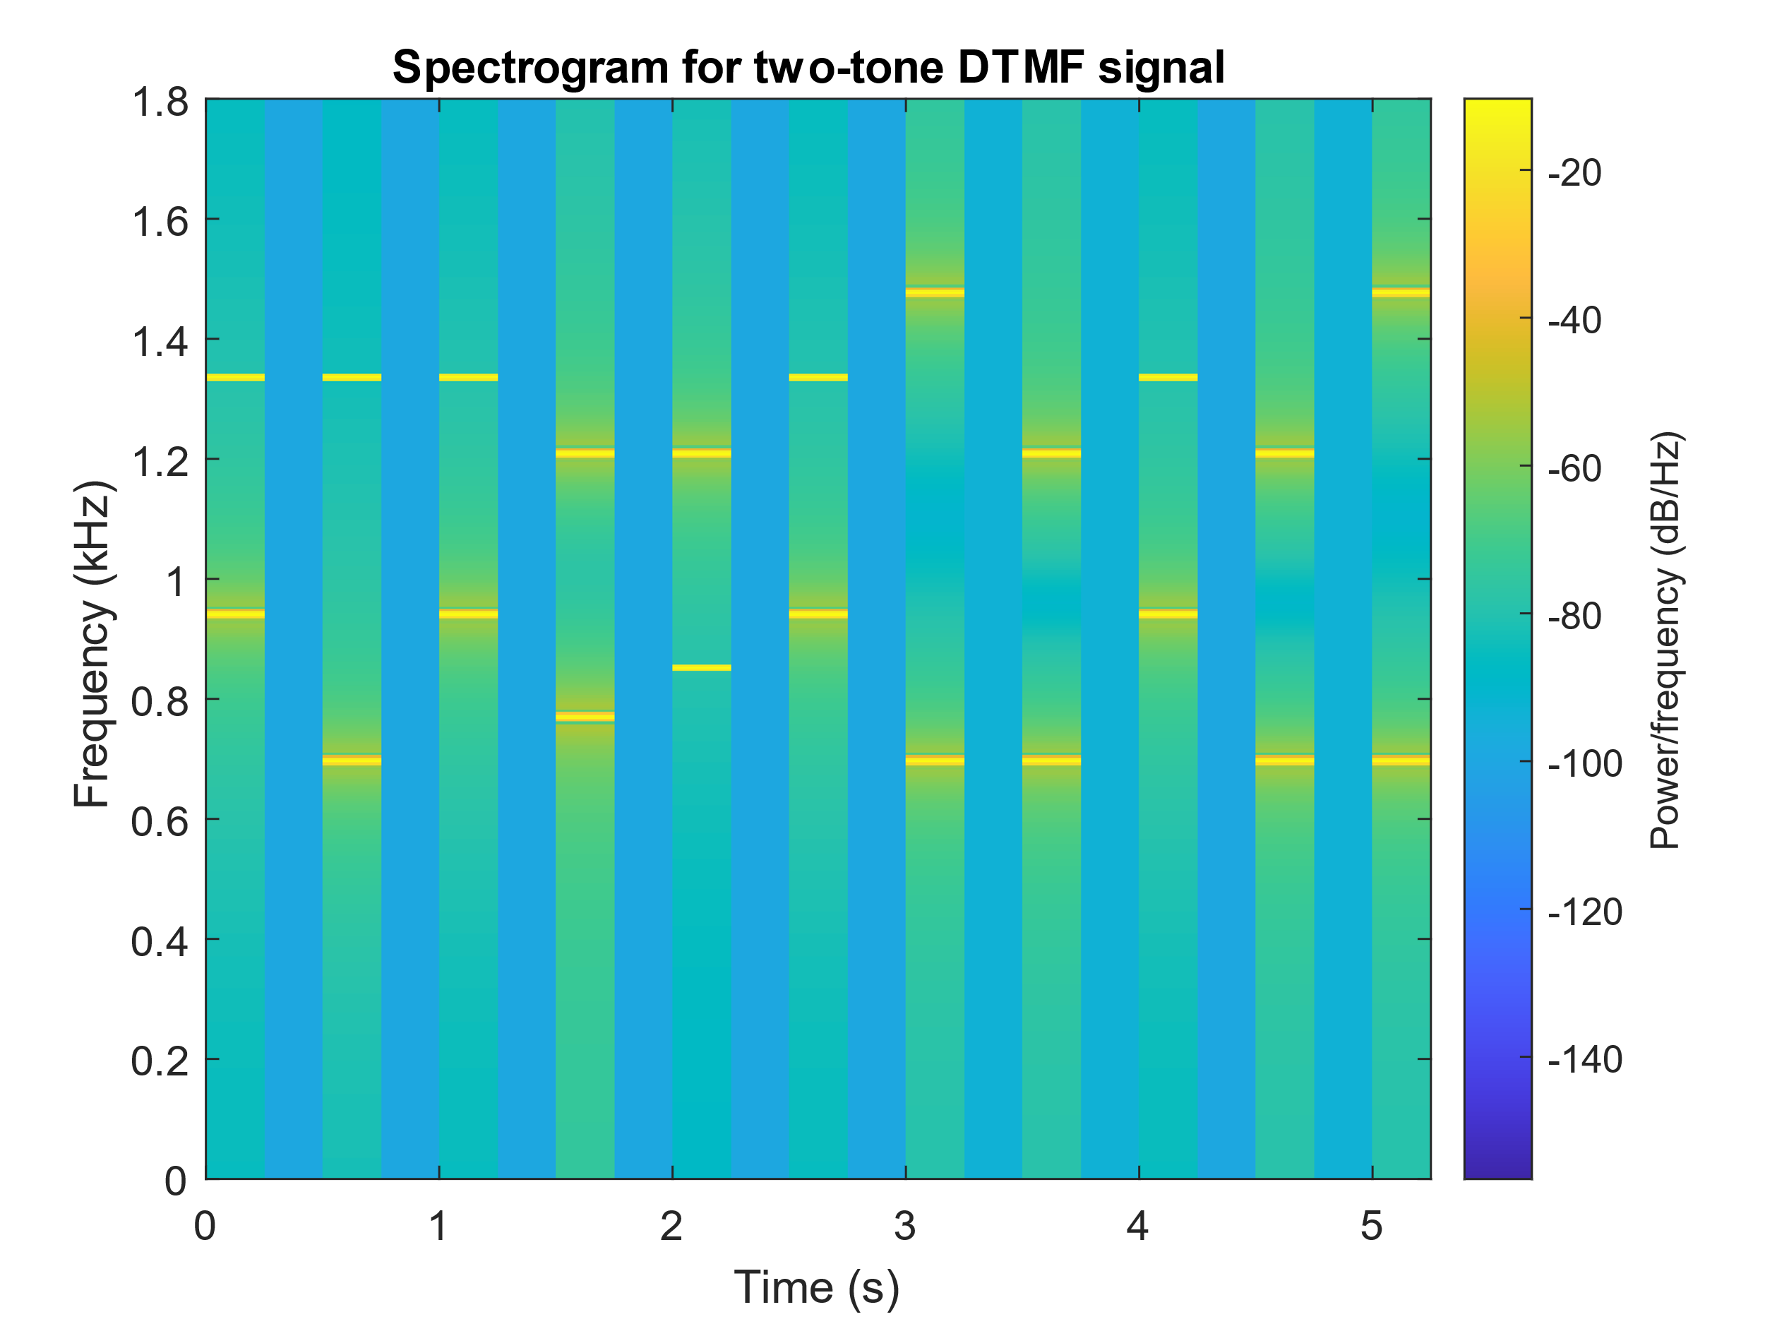

### Key classification

As seen in the above figure, there are clear peaks in the power spectra, corresponding to the dial pad two-tone frequencies. The signal has been separated into 21 sections of 0.25s durations, alternating between key presses and idleness. The bars with no apparent peaks in power spectra correspond to the idle time between key presses.

Due to the clear peak frequencies present it is possible to identify the key pressed by comparing the peak frequencies to the dial pad frequencies table [insert]. Due to the Hanning window used, there is a slight decrease in frequency resolution, so an error margin of around $±$ 20Hz should be introduced when comparing to the look up table. Finite window length means PSD is not ideal as well.

### Corruption by channel noise

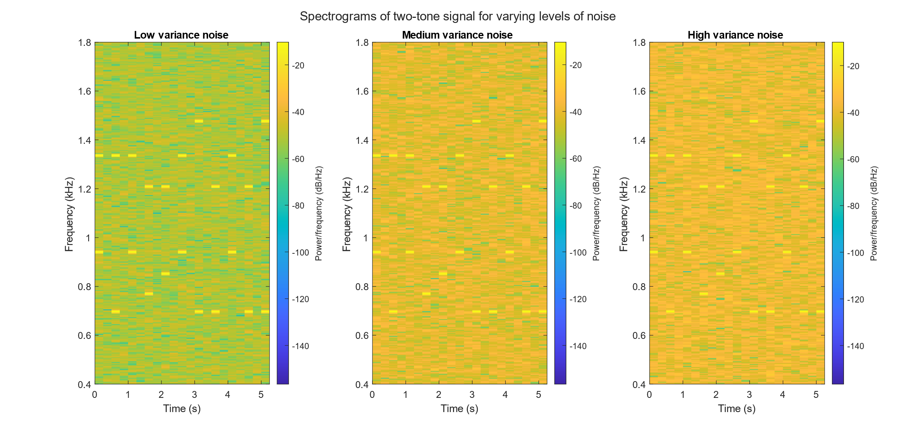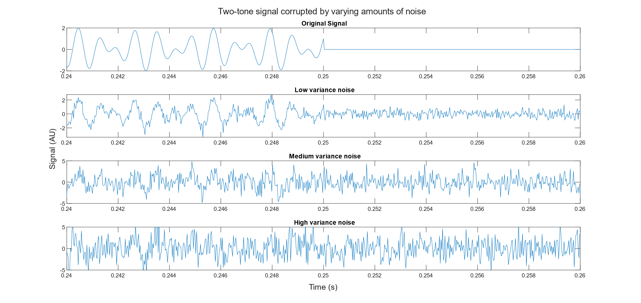

## Respiratory sinus arrhythmia from RR-Intervals

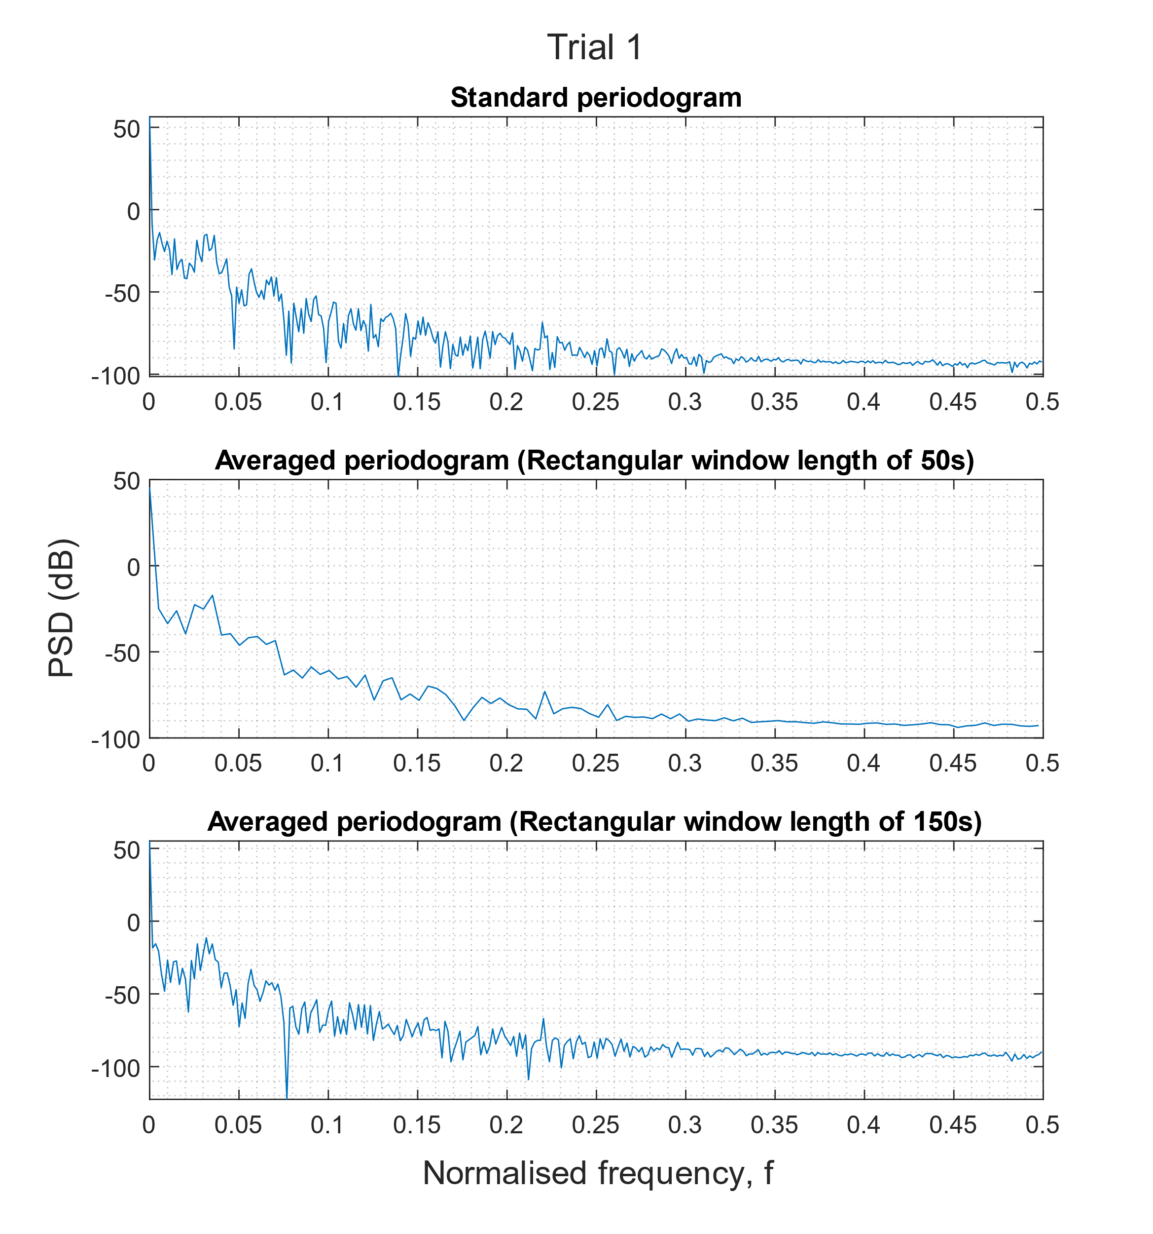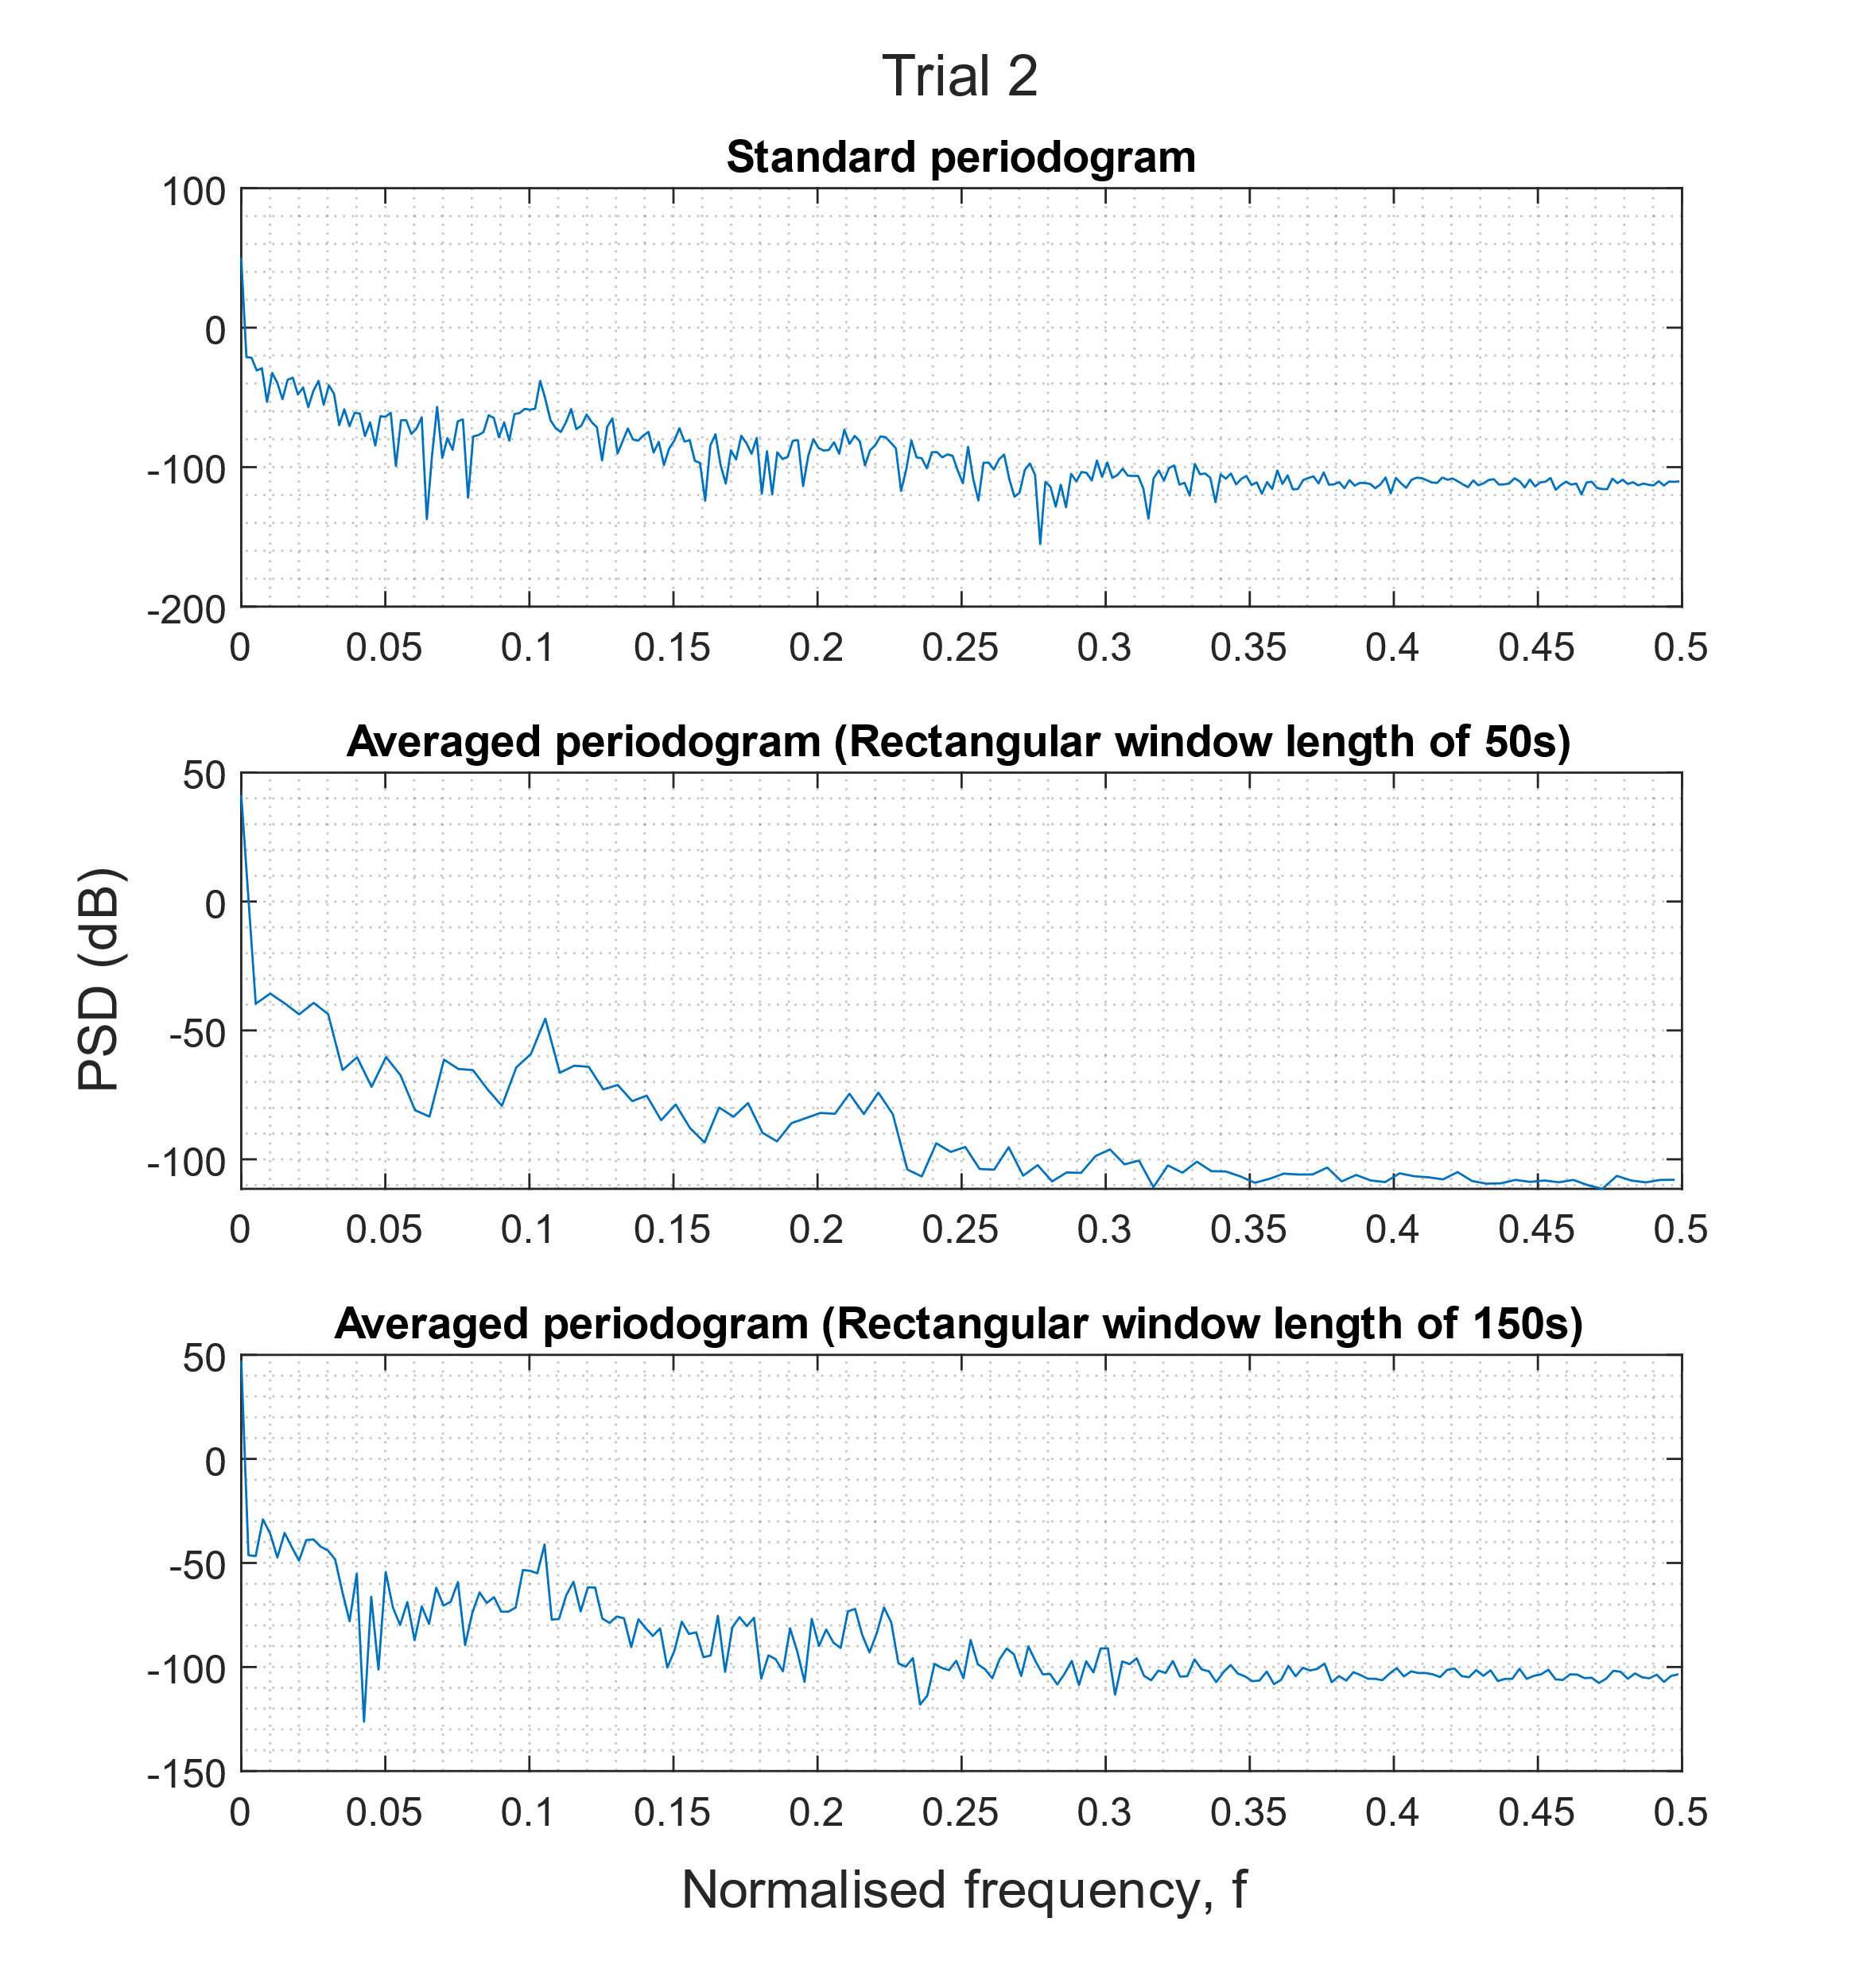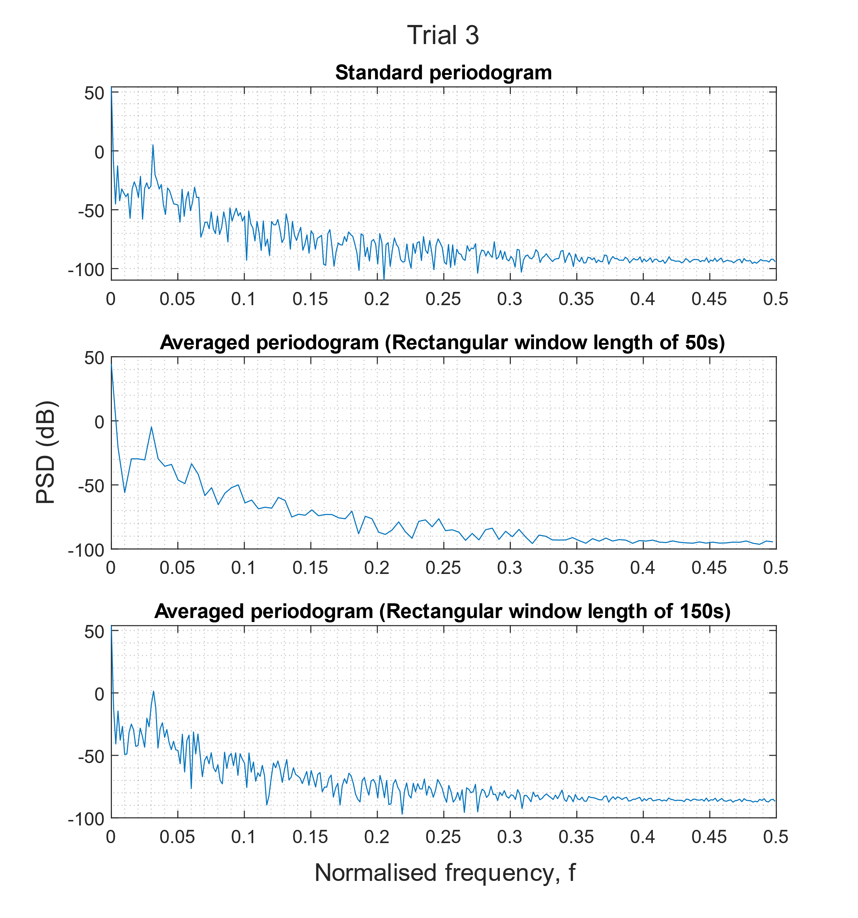

# Optimal filtering – fixed and adaptive

## Wiener filter

SNR = Ratio of power = var(y)/var(zeta) = 1 / 0.1 = 10 = 20 dB

### Statistics and optimal coefficients of the Wiener filter

wopt =

0.2405

0.4445

0.6802

0.4363

0.2225

ans = after * sqrt of sum of squared b values

1.0481

1.9376

2.9651

1.9020

0.9700

### Differing observation variance

|  |  |  |  |  |  |  |  |  |
| --- | --- | --- | --- | --- | --- | --- | --- | --- |
| Variance | w0 | w1 | w2 | w3 | w4 | SNR (dB) | | MSE |
| 0.1000 | 0.9832 | 2.1158 | 3.0864 | 2.1135 | 1.0620 | 20 | 0.0076 | |
| 0.2512 | 1.0482 | 2.2192 | 3.1862 | 2.0764 | 1.0919 | 12 | 0.0199 | |
| 0.6310 | 0.8420 | 2.1479 | 2.9283 | 2.1459 | 0.9952 | 4 | 0.0147 | |
| 1.5849 | 1.3584 | 1.9129 | 2.9432 | 1.8544 | 0.9265 | -4 | 0.0332 | |
| 3.9811 | 1.2764 | 2.1504 | 3.1888 | 2.1490 | 1.3317 | -12 | 0.0534 | |
| 10.0000 | 1.0768 | 1.7313 | 3.8192 | 2.7395 | 1.2496 | -20 | 0.2716 | |

|  |  |  |  |  |  |  |  |  |  |  |  |
| --- | --- | --- | --- | --- | --- | --- | --- | --- | --- | --- | --- |
| Order | w0 | w1 | w2 | w3 | w4 | w5 | w6 | w7 | w8 | w9 | w10 |
| 4 | 1.0510 | 2.1057 | 3.0770 | 2.1380 | 1.0300 | 0.0000 | 0.0000 | 0.0000 | 0.0000 | 0.0000 | 0.0000 |
| 5 | 1.0874 | 2.0124 | 3.1643 | 2.0153 | 0.9682 | 0.0569 | 0.0000 | 0.0000 | 0.0000 | 0.0000 | 0.0000 |
| 6 | 1.0952 | 2.0213 | 3.0654 | 2.0412 | 0.9996 | -0.0080 | -0.0239 | 0.0000 | 0.0000 | 0.0000 | 0.0000 |
| 10 | 1.0996 | 2.0973 | 3.1207 | 2.0074 | 1.0394 | 0.0487 | 0.0061 | 0.0033 | -0.0068 | 0.0090 | 0.0290 |

|  |  |
| --- | --- |
| Order | MSE |
| 4 | 0.007934 |
| 5 | 0.007206 |
| 6 | 0.003096 |
| 10 | 0.007113 |

### Computational complexity of Wiener solution

Wopt = Rxx^-1 * pzx where Rxx is (Nw +1) x (Nw + 1) matrix and pzx = (Nw + 1) x 1 vector.

The number of operations to find the inverse of an arbitrary $N × N$ matrix is of the order of magnitude *O $\left(N^{3}\right)$*. Therefore, to compute the inverse of $R_{xx}$, the number of operations is $O\left({\left(N_{w}+1\right)}^{3}\right)≈O\left(N_{w}^{3}\right)$. The resulting matrix $R_{xx}^{-1}$, is also of dimension $\left(N_{w}+1\right)×\left(N_{w}+1\right)$ so the resulting vector will be of dimension $\left(N_{w}+1\right)× 1$. To compute each element in Wiener solution vector, there is a dot product from the row of the matrix $R_{xx}^{-1}$ and the vector $p_{zx}$, meaning $\left(N_{w}+1\right)$ scalar multiplications and $N_{w}$ scalar additions. As a result, to compute the entire solution vector, you require $O\left(N_{w}^{3}\right)$ operations + $\left(N_{w}+1\right) ⋅\left(N_{w}+1\right)$ scalar multiplications and $\left(N_{w}+1\right) ⋅\left(N_{w}\right)$ scalar additions.

## The least mean square (LMS) algorithm

### LMS algorithm implementation

|  |  |  |  |  |
| --- | --- | --- | --- | --- |
| $$w_{0}$$ | $$w_{1}$$ | $$w_{2}$$ | $$w_{3}$$ | $$w_{4}$$ |
| 0.9782 | **2.0349** | **2.9804** | **2.0734** | **0.9652** |

### Time evolution of estimated coefficients

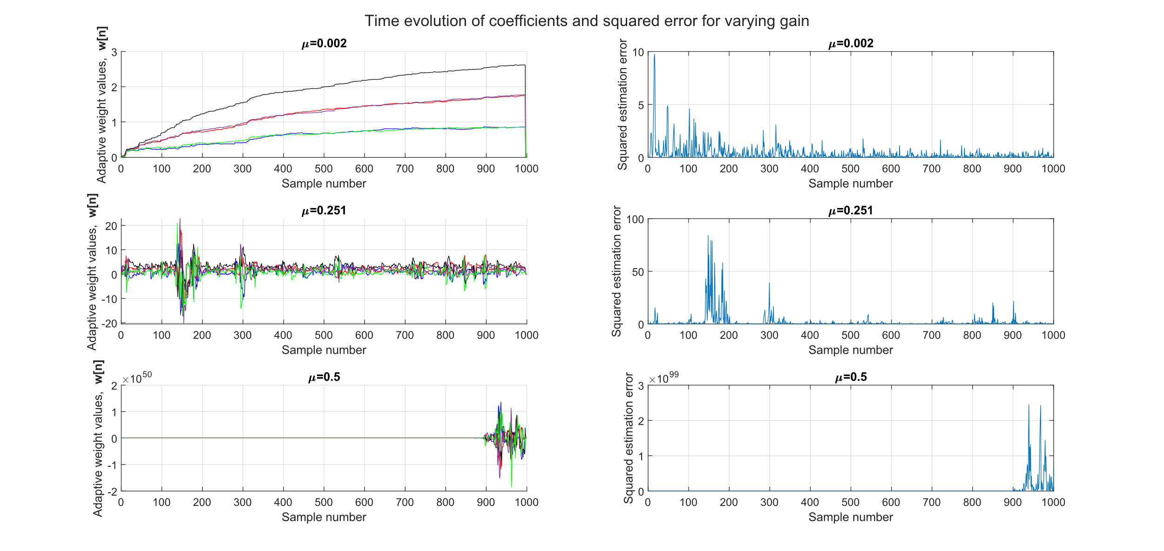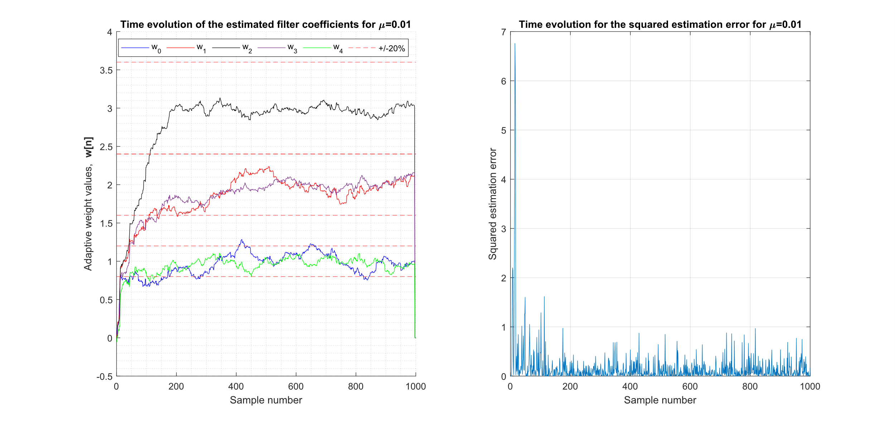

### Computational complexity of LMS algorithm

The LMS algorithm is determined by the following three equations:

$$w\left(n+1\right)=w\left(n\right)+μe\left[n\right]x\left(n\right), n=0,1,…$$

$$\hat{y}\left[n\right]=w^{T}\left(n\right)x\left(n\right)=\sum_{m=0}^{N_{w}}{w_{m}x\left(n-m\right)}$$

$$e\left[n\right]=z\left[n\right]-\hat{y}\left[n\right]$$

For one time step, the first equation would have operations on the order $O\left(N_{w}\right)$, the second equation would be $O\left(N_{w}\right)$, as well as the last equation. For N time steps we would have a total computational complexity of $O\left(N_{w}N\right)$.

## Gear Shifting

0.05 (threshold for target error) * mag(b) ~ 0.2. Can see estimates converge just within this limit. Rise time much shorter, but biased estimates, didn’t converge to global minima due to decaying learning rate.

## Identification of AR Process

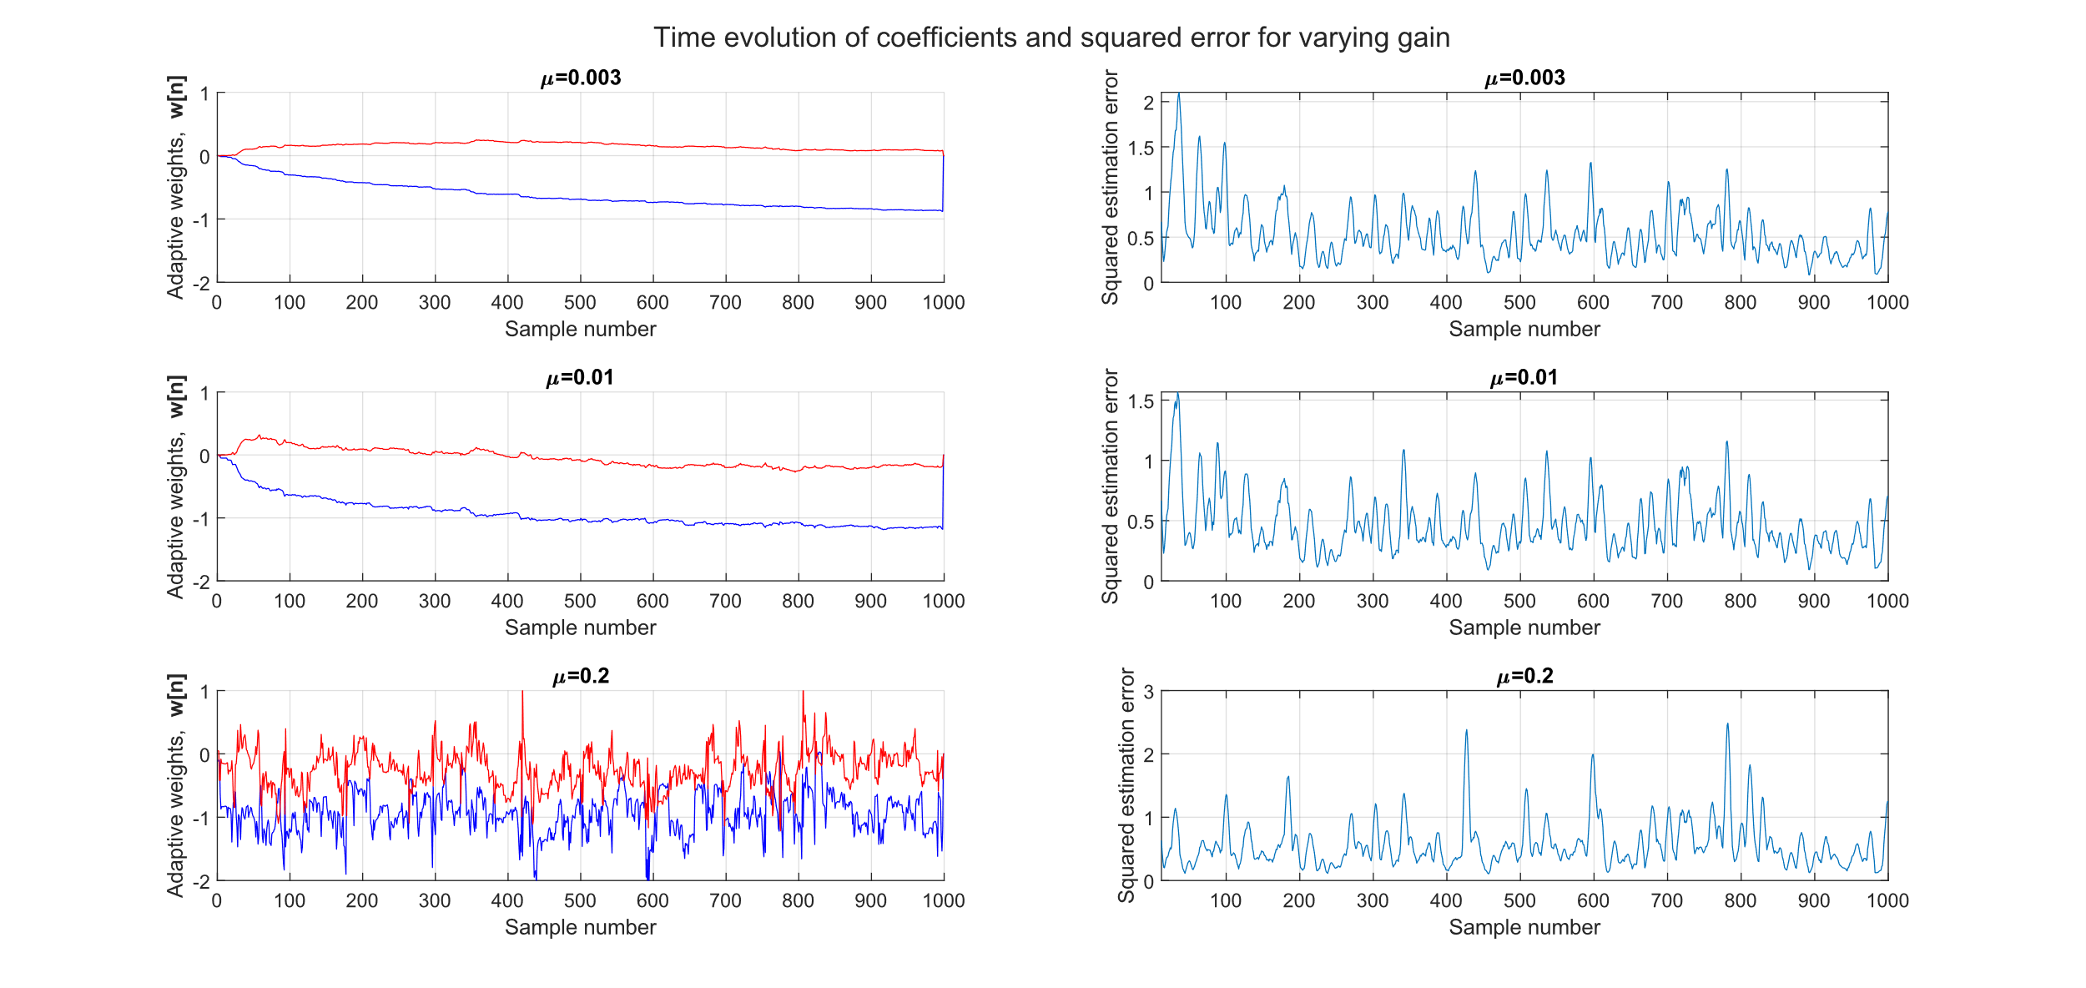

## Speech recognition

### Performance of $p^{th}$ order predictor

Voice recordings corresponding to the sounds “e”, “a”, “s”, “t”, “x” were sampled at a frequency of $f_{s}$ = 44100Hz, with a length of N = 1000 samples. By providing the adaptive AR filter with a delayed version of the input sound, the estimator served as a predictor. Below are plots displaying the predictions alongside the recorded signals for varying predictor orders.

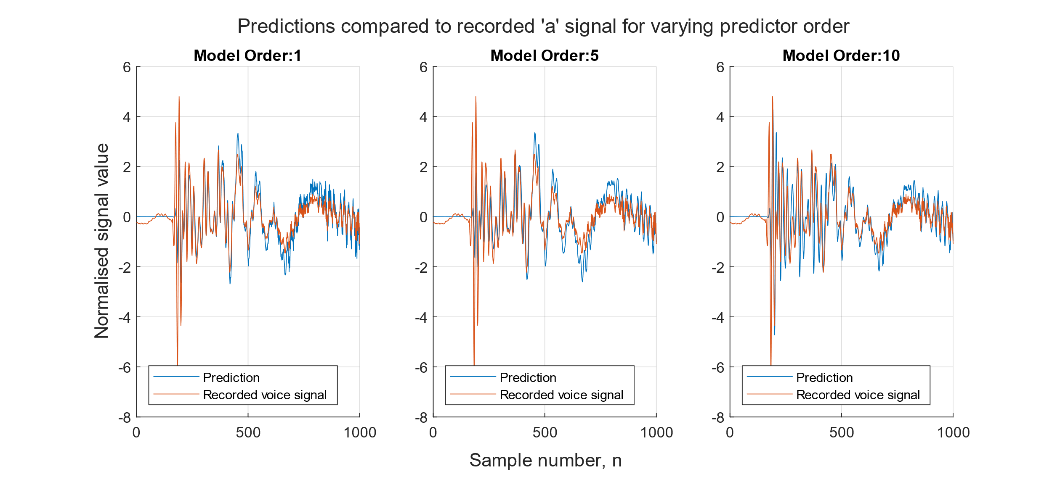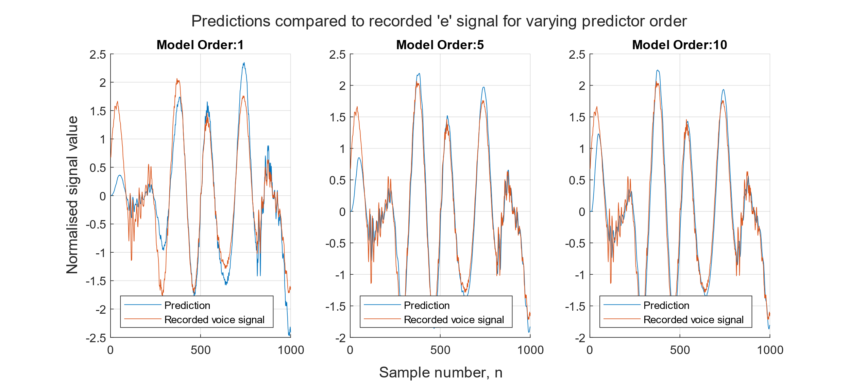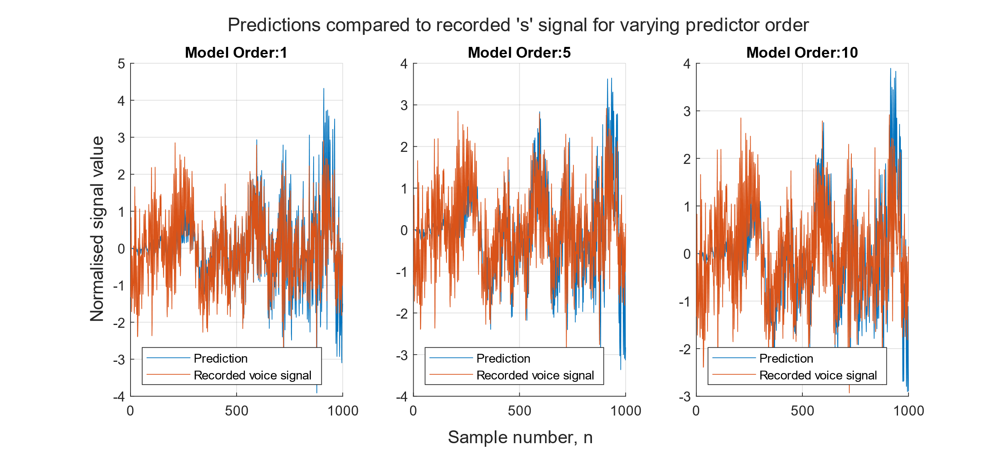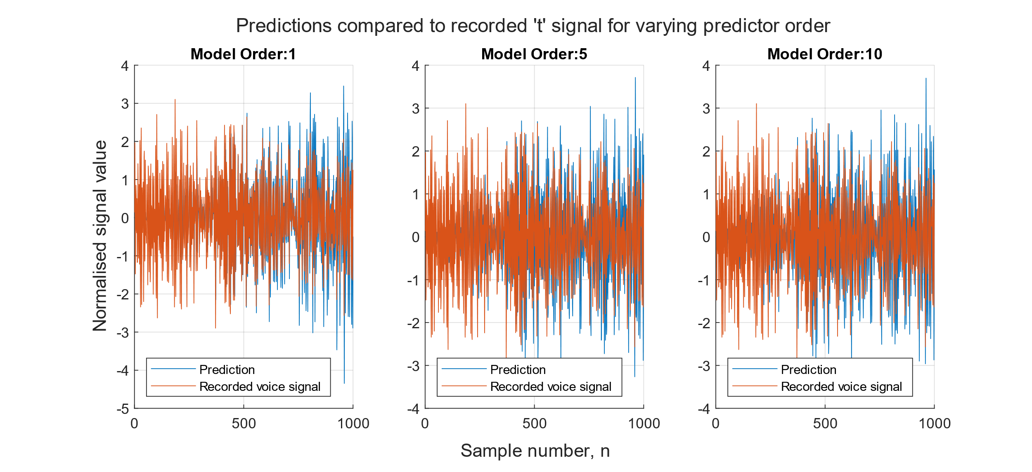

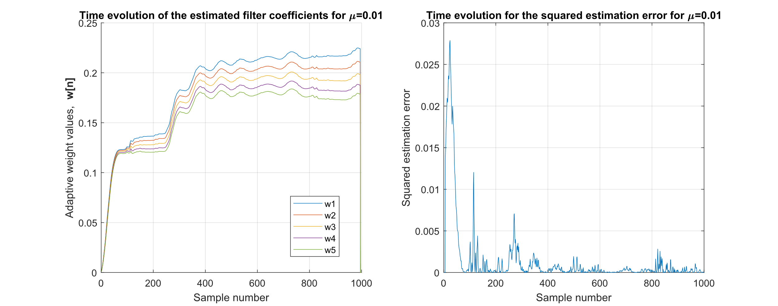An adaptation gain of 0.1 was used to attain the plots above, after trialling a selection of values ranging from [0.002, 1.5]. Small adaptation gains lead to poor estimates since the non-stationarity of the signals meant that the filter parameters could not be updated quick enough. Adaptation gains larger than 1 lead to diverging parameter estimates. Similarly, gear shifting was not appropriate since it is designed for use with stationary signals, whereas voice recordings are non-stationary. Increasing the predictor order did not seem to improve performance significantly, suggesting that the computational effort required to compute higher orders is not justified.

### Optimal filter length

A standard measure for the performance of a predictor we can use is the predictor gain

$$R_{p}=10\log_{10}{\frac{σ_{x}^{2}}{σ_{e}^{2}}} ,$$

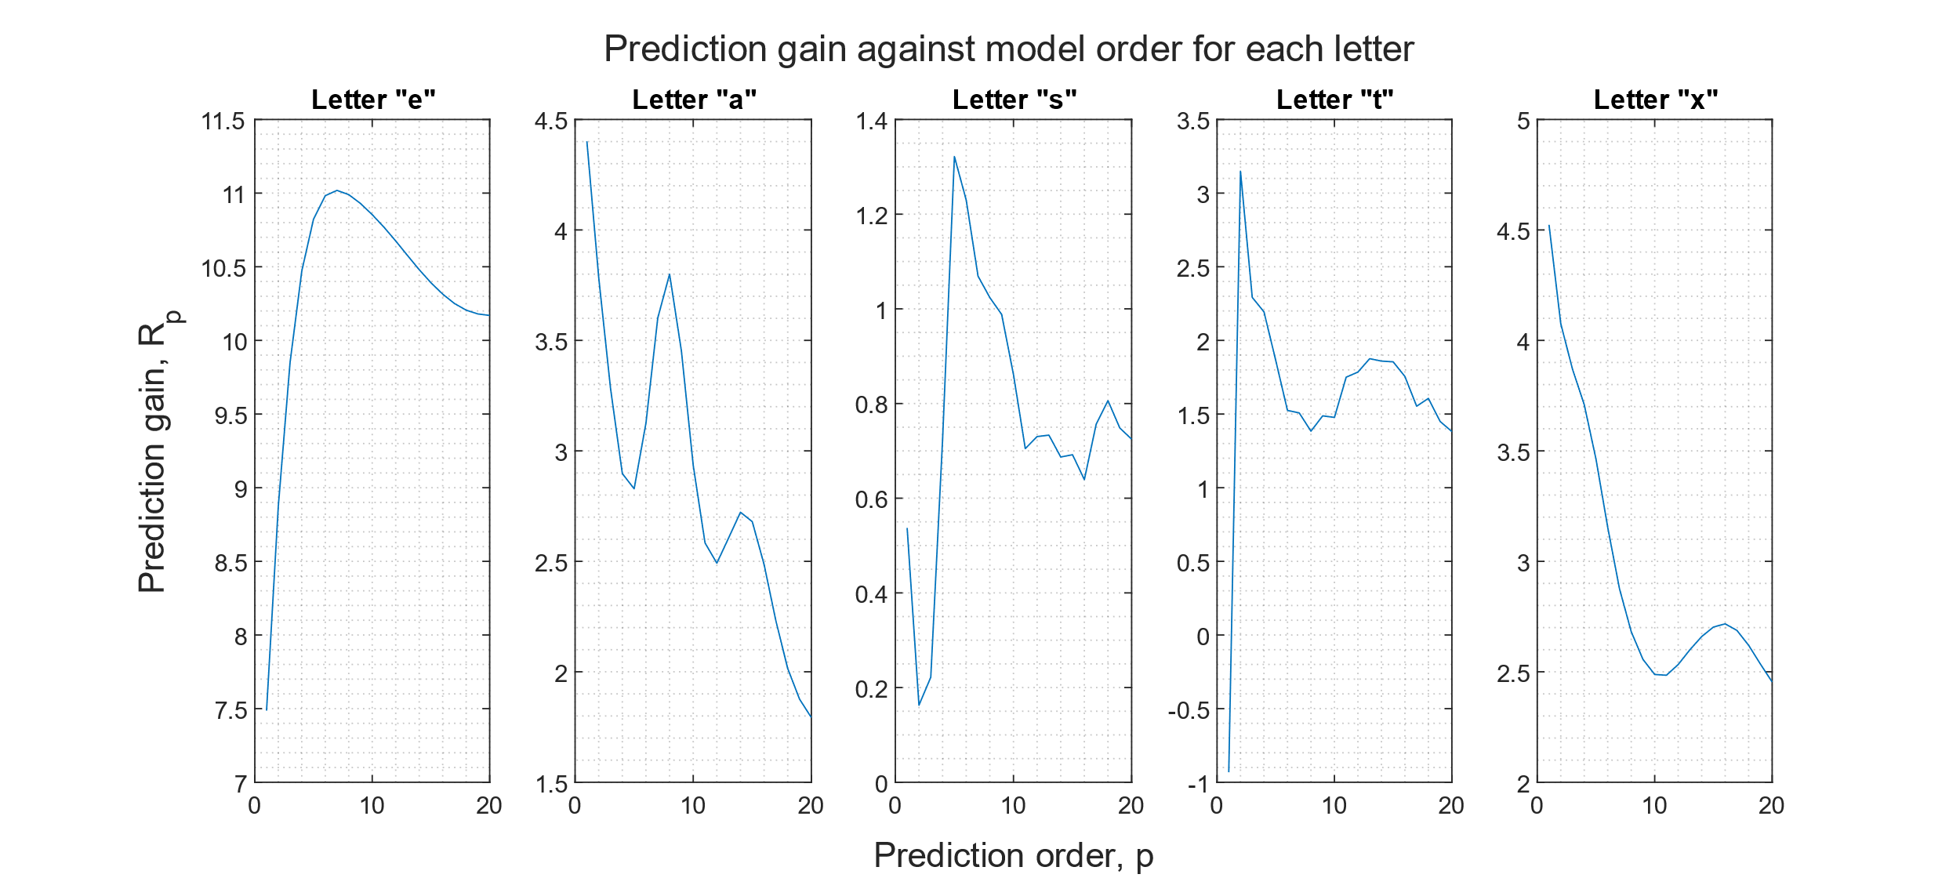where $σ_{x}^{2}$ and $σ_{e}^{2}$ denote the variance of the input and error signals respectively. Thus we can select an optimal predictor order by maximising $R_{p}$. By examining the peaks in the plots below, we observe that the optimal predictor orders for the “e”, “a”, “s”, “t”, “x” signals are p = 7, 1, 5, 2 and 1 respectively.

Information theoretic criterion such as MDL or AIC could also be utilised, where the order corresponding to the minima would be considered optimal.

It is worth noting that the prediction gain is significantly higher for “e” than any other letter. This may be explained by the plots in Section 4.5.1, where the “e” signal appears to be quasi-stationary, allowing it to be more effectively modelled by an AR filter. For the other vowel, “a”, there’s also a secondary peak at p = 8, similar to that of “e”, suggesting that vowels may be more quasi-stationary that the consonants, and so more appropriately modelled by this filter.

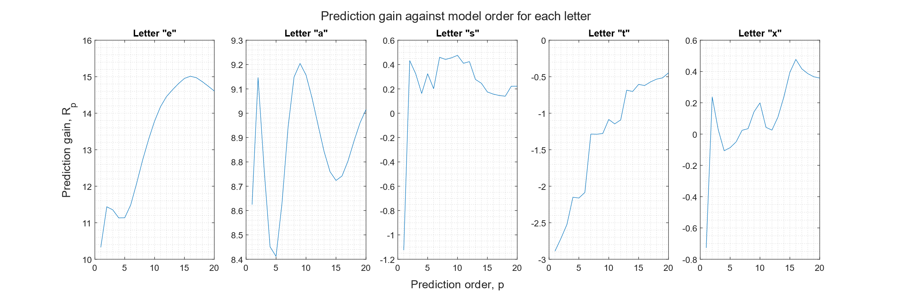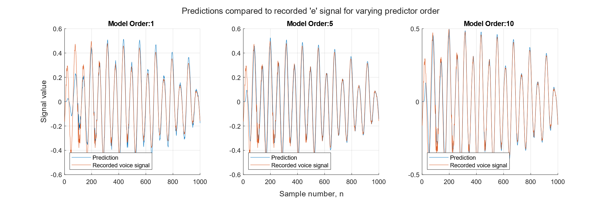

When using the lower sampling frequency of $f_{s}$ = 16000 Hz, vowels tended to remain with higher prediction gains, whereas the consonant’s prediction gains decreased by 1-4 dB, or approximately halving the signal to error power ratio. This could be explained by a consonant having a wider bandwidth, B, than a vowel, such that the new sampling frequency is less than the Nyquist rate, or $f_{s}<2B$. Therefore for a given period of continuous time, $Δt$, a minimum number of samples, $N=f_{Nyquist}Δt = 2Bt$, is needed to avoid information loss and degradation in estimator performance. This also applies to the bandwidth of the vowels, where a minimum number of samples is required to ensure quasi-stationarity and the convergence of learning curves.

## Dealing with computational complexity, sign algorithms

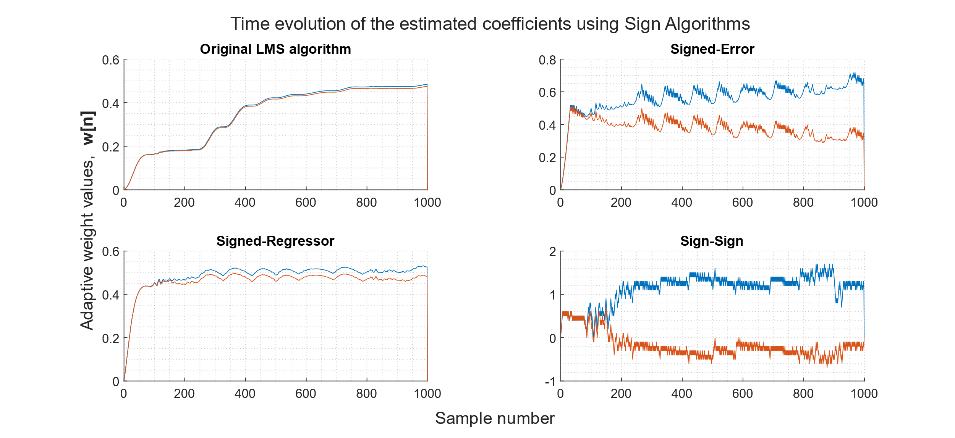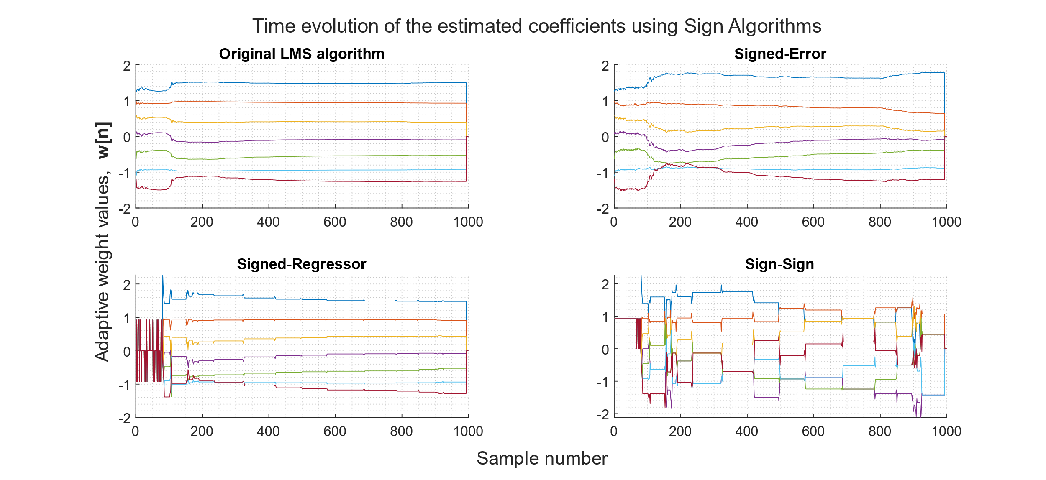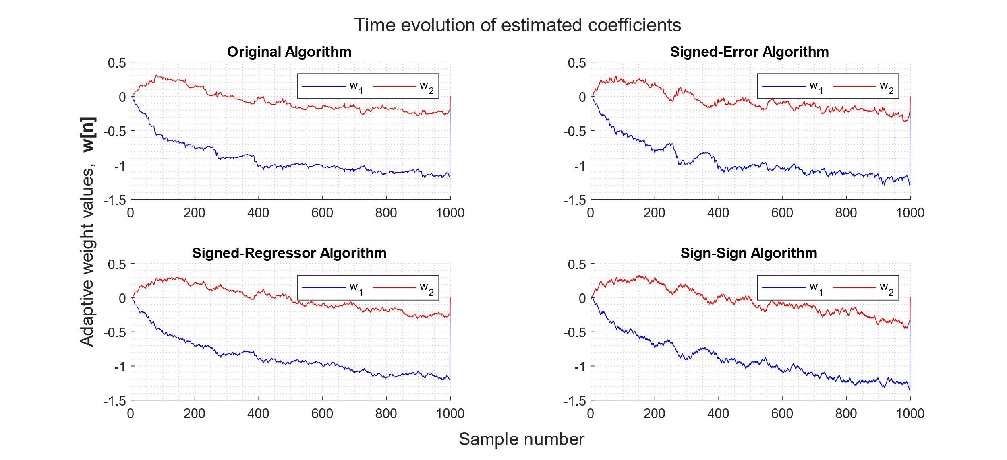

|  |  |  |  |  |
| --- | --- | --- | --- | --- |
| $$R_{p}$$ | Original | Signed-Error | Signed-Regressor | SS |
| p=2 | 7.8984 | 16.1148 | 14.9329 | 16.1658 |
| p=7 | 10.9670 | 15.6348 | 15.0593 | 7.4938 |